

**UNIVERSITI TEKNIKAL MALAYSIA MELAKA**

FACULTY OF INFORMATION AND COMMUNICATION TECHNOLOGY

W O R K S H O P 1

R E P O R T

|  |  |
| --- | --- |
| **Name** | : CHONG KHIUN CHIEN |
| **Matric Number** | : B032410160 |
| **Program** | : BITC |
| **Project Title** | : StreetJobRecruit System |
| **Supervisor Name** | :PROFESOR MADYA GS. TS. DR. OTHMAN BIN MOHD |
| **Evaluator Name** | : TS. DR. NOR AZMAN BIN MAT ARIFF |

# EXECUTIVE SUMMARY

The StreetJobRecruit System is designed to help job seekers and employers track and organize career opportunities, which will ultimately boost hiring productivity and professional growth. The main headache right now is the scattered and often manual way job data is stored, which creates a messy barrier between talent and companies. Relying on these human-heavy procedures leads to major issues: first, when a huge amount of data is handled through informal social media posts or printed ads, errors like missing details or outdated listings are bound to happen; secondly, manually finding or tracking applications is a total time-sink that results in slow hiring rates and major delays in meeting workforce demand. My goal is to create a centralized recruitment system that is so well-designed that users instantly vibe with how it works. Next, I need to evaluate how well this system facilitates ease of use to identify and fix any vulnerabilities so I can improve on the previous, disorganized performance. This platform allows the database to store all data related to user profiles, job descriptions, and application statuses, where users can add, remove, modify, search, and view data to keep the hiring process moving. Depending on the module, the system offers smart calculation capabilities, such as automatically tracking the total number of applicants per job for the target users: job seekers, employers, and administrators. In conclusion, this initiative is a total productivity cheat code that saves time and money, making data administration easier than ever since the system calculates applicant volume automatically, so staff don't have to stress about it.

# TABLE OF CONTENTS

|  |  |
| --- | --- |
|  | **PAGE** |

EXECUTIVE SUMMARY i

TABLE OF CONTENTS ii

LIST OF TABLES v

LIST OF FIGURES vi

Chapter 1: INTRODUCTION 1

1.1 Introduction 1

1.2 Problem Statement 2

1.3 Objective (s) of the project 2

1.4 Scope 3

1.4.1 Modules to be developed 3

1.4.2 Target User 4

1.5 Project Significance 5

1.6 Gantt Chart of Project Activities 7

Chapter 2: ANALYSIS OF PROBLEM 8

2.1 Problem Decomposition Description 8

2.2 Structured Chart 9

Chapter 3: DESIGN 10

3.1 Business Rules 10

3.2 Flowchart 12

3.2.1 System Flowchart 12

3.1.1 Seeker Flowchart 13

3.1.2 Employer Flowchart 14

3.1.3 Admin Flowchart 15

3.3 ERD 21

3.4 Data Normalization 22

3.5 Data Dictionary 23

3.6 Interface Design 26

3.6.1 Menu Login 26

3.6.2 Seeker Interface 29

3.6.3 Employer Interface 33

3.6.4 Admin Interface 42

Chapter 4: IMPLEMENTATION 71

4.1 Naming Convention 71

4.2 Function 72

4.3 Array 73

4.4 Selection 73

4.5 Control 74

4.6 Pointer 75

4.7 Error Handling 76

4.8 Business Rule Implementation 77

4.9 Complex Calculation Implementation 77

4.10 Report Generation for Analysis Implementation 78

Chapter 5: CONCLUSION 79

5.1 Constraints 79

5.2 Future Improvements 79

REFERENCES 80

# LIST OF TABLES

|  |  |
| --- | --- |
|  | **PAGE** |

Table 2.1.1 ANALYSIS OF PROBLEM 8

Table 3.4.1 Data Normalization 22

Table 3.5.1 User 23

Table 3.5.2 Job 23

Table 3.5.3 Application 24

Table 3.5.4 User Skill 24

Table 3.5.5 Job Skill 24

Table 3.5.6 Seeker Education 25

Table 3.5.7 Seeker Language 25

Table 3.5.8 Seeker License 26

# LIST OF FIGURES

|  |  |
| --- | --- |
|  | **PAGE** |

Figure 1.6.1 Gantt Chart of Project Activities 7

Figure 2.2.1 Structured Chart 9

Figure 3.2.1.1 System Flowchart 12

Figure 3.1.1.1 Seeker Flowchart 13

Figure 3.1.2.1 Employer Flowchart 14

Figure 3.1.3.1Admin Menu 15

Figure 3.1.3.2 Admin View All Users 16

Figure 3.1.3.3 Admin View All Jobs 16

Figure 3.1.3.4 Admin View All Applications 17

Figure 3.1.3.5 Admin View All Skills 17

Figure 3.1.3.6 Admin View Job Skills 18

Figure 3.1.3.7 Admin View User Skills 18

Figure 3.1.3.8 Admin View Seeker Education 19

Figure 3.1.3.9 Admin View Seeker Languages 19

Figure 3.1.3.10 Admin View Database Statistics and Search 20

Figure 3.1.3.11 Admin Report Generation 20

Figure 3.3.1 ERD 21

Figure 3.6.1.1 Loading Menu Interface 26

Figure 3.6.1.2 Menu Welcome 27

Figure 3.6.1.3 Menu 27

Figure 3.6.1.4 Register User 28

Figure 3.6.1.5 Login Page 29

**Figure 3.6.2.1 Seeker Menu** 29

Figure 3.6.2.2 Seeker View/Filter Available Jobs 30

Figure 3.6.2.3 Seeker Filter by Location 30

Figure 3.6.2.4 Seeker View Job Details 31

Figure 3.6.2.5 Seeker Apply for a Job 31

Figure 3.6.2.6 Seeker View My Applications 32

Figure 3.6.2.7 Seeker Update Profile 32

Figure 3.6.2.8 Seeker Update Summary 33

Figure 3.6.3.1 Employer Menu 33

Figure 3.6.3.2 Employer Manage Posted Jobs 34

Figure 3.6.3.3 Employer Delete Job 34

Figure 3.6.3.4 Employer Post New Job 35

Figure 3.6.3.5 Seeker Update Job 35

Figure 3.6.3.6 Employer Update Job Type 36

Figure 3.6.3.7 Employer Update Salary 37

Figure 3.6.3.8 Employer Manage Applications 37

Figure 3.6.3.9 Employer Filter by Status 38

Figure 3.6.3.10 Employer Update Status 39

Figure 3.6.3.11 Employer Delete Application 39

Figure 3.6.3.12 Employer Search My Jobs 40

Figure 3.6.3.13 Employer Active Toggle Status 40

Figure 3.6.3.14 Employer Analytics Summary 41

Figure 3.6.3.15 Employer Monthly Stats Report 41

Figure 3.6.4.1 Admin Menu 42

Figure 3.6.4.2 View All Users 42

Figure 3.6.4.3 Admin Filter by Role 43

Figure 3.6.4.4 Admin Filter By Location 44

**Figure 3.6.4.5 Admin Search** 45

Figure 3.6.4.6 Admin Create User 46

Figure 3.6.4.7 Admin Update User 47

Figure 3.6.4.8 Admin Delete User 47

Figure 3.6.4.9 Admin View All Jobs 48

Figure 3.6.4.10 Admin Update Job 48

Figure 3.6.4.11 Admin Delete Job 49

Figure 3.6.4.12 Admin Search App Id 50

Figure 3.6.4.13 View User Skills 51

Figure 3.6.4.14 Admin Create Skill 52

Figure 3.6.4.15 Admin Update Skill 52

Figure 3.6.4.16 Admin Delete Skill 53

Figure 3.6.4.17 Admin View User Skills 54

Figure 3.6.4.18 Admin View Job Skill 55

Figure 3.6.4.19 Admin View Seeker Education 56

Figure 3.6.4.20 Admin Filter By Qualification 57

Figure 3.6.4.21 Admin Add Education Record 58

Figure 3.6.4.22 Admin Update Education 58

Figure 3.6.4.23 Admin View Seeker Languages 59

Figure 3.6.4.24 Admin Update Proficiency 60

Figure 3.6.4.25 Admin View Database Statistics 61

Figure 3.6.4.26 Admin Job Posting Summary 62

Figure 3.6.4.27 Admin Applicants Per Job 63

Figure 3.6.4.28 Admin App Status Breakdown 64

Figure 3.6.4.29 Admin Most Applied Categories 65

Figure 3.6.4.30 Admin Registered Users Breakdown 66

Figure 3.6.4.31 Admin Conversion Rate Report 66

Figure 3.6.4.32 Job Competition Index 67

Figure 3.6.4.33 Admin Demand vs Supply Report 68

Figure 3.6.4.34 Admin Monthly App Statistics 69

Figure 3.6.4.35 Admin GENERATE ALL REPORTS 70

Figure 4.1.1 Naming Convention 71

**Figure 4.2.1 Function** 72

Figure 4.3.1 Array 73

Figure 4.4.1 switch statements 74

Figure 4.4.2 if-else statements 74

Figure 4.5.1 Control 75

Figure 4.6.1 Pointer 75

Figure 4.7.1 try-catch Blocks 76

Figure 4.7.2 Input Stream Validation 76

**Figure 4.8.1 Business Rule Implementation** 77

Figure 4.9.1 Complex Calculation Implementation 78

Figure 4.10.1 Visual Rendering 78

---- 0

# INTRODUCTION

## Introduction

Job recruitment platforms are essential digital spaces that provide bridges for individuals looking for employment and companies seeking talent in a competitive market. The primary benefit of the StreetJobRecruit System is that its design allows users to search for and manage career opportunities safely at any time, even when the local job market is disorganized. Therefore, to be able to achieve such things, good facilities must be developed to ensure that users will return to the platform to find work whenever they need it. This will create value for the platform’s administrators and the professional ecosystem. Unfortunately, having many job seekers and listings is not enough to attract people if the platform does not have a proper management system.

The StreetJobRecruit System will assist recruitment hubs by managing administrative tasks such as overseeing user accounts and job categories, as well as generating reports for administrators to analyse what happens with their hiring metrics. Next, in this system, the admin can view all user and job advertisement data in the database. As a result, it makes the administrative job much easier to manage.

For employers, they work as a connector between job seekers and the final hiring decision. All applicants will be managed by them, including the registration of job ads and the tracking of submissions. Therefore, employers can also manage the applicants, including searching, viewing, and updating application progress. This will help candidate management stay properly organized. Next, for registered job seekers, they do not need to register their personal details again when they come back because their profile data has been saved in the database. They can go straight to the search listings to make an application.

The purpose of this system development is to improve the efficiency of the hiring process and, at the same time, improve the quality of the recruitment database. With this system in hand, career management will be easy to access, and data can be well organized.

## Problem Statement

Based on my observations, the current way job recruitment is handled still relies heavily on informal social media posts and manual notes, which then must be keyed into basic Excel sheets to keep any kind of record. This manual setup seriously drags down the speed of user registration and makes tracking job applications a total chore. Next, employers are still stuck calculating the total number of applicants per job by hand, which wastes everyone’s time and leaves candidates stuck in a long, frustrating hiring queue.

The reporting side of things is also a mess; staff must take data from informal chats or paper notes and key it into spreadsheets just to generate a basic hiring report. This slow workflow is an open invitation for human error, where candidate details get lost, or staff simply forget to key in data they previously wrote down.

As for the solution, the recruitment process needs a dedicated system that provides an organized inventory of users, job postings, and applications, while also handling the heavy lifting of calculating applicant totals automatically. By moving everything into a centralized database, the system will cut out these time-consuming manual tasks and kill off human error. This will result in professional, high-quality recruitment reports that give employers and job seekers the clear data they need.

## Objective (s) of the project

This project embarks on the following objectives:

1. To implement **3** modular functionalities with **CRUDS** (Create, Read, Update, Delete, Search) database management for the **StreetJobRecruit System**:
   * **User Management Module** to manage job seeker and employer information.
   * **Job Posting Module** to allow employers to create and manage job advertisements.
   * **Job Application Module** to enable job seekers to apply for and track job applications.
2. To implement **complex calculations,** including the **total number of applicants per job,** to support decision-making and data analysis.
3. To develop **analytical reports** for the **StreetJobRecruit System**, including application summaries, job posting statistics, and user activity reports to provide valuable insights for employers and job seekers.

## Scope

### Modules to be developed

1. **User Management Module**

* This module manages the professional identities and profiles of all platform participants, including job seekers, employers, and administrators.
* It provides secure registration and login functionalities to ensure data privacy and authorized access control.
* Users can maintain and update their personal or company information, such as contact details and professional skills, through a centralized interface.

1. **Job Posting Management Module**

* This module empowers employers to oversee the full lifecycle of their job advertisements within the system.
* It includes comprehensive tools to create new job posts, modify existing listing details, and remove outdated or filled positions.
* The module ensures all job data is well-organized by utilizing standardized categories for skills, salaries, and requirements.

1. **Job Application Management Module**

* This module facilitates the direct connection between talent and opportunity by managing the submission workflow.
* Job seekers can submit digital applications and monitor their progress through real-time statuses like "Pending," "Shortlisted," or "Hired.
* Employers utilize this module to review candidate profiles and update application statuses to keep the hiring process transparent.

1. **Report Generation & Analytics Module**

* This module focuses on high-level data analysis to improve recruitment productivity and provide system insights.
* It performs complex calculations, such as automatically determining the total number of applicants for each specific job posting.
* The system generates various analytical reports, including hiring trends and application summaries, to support data-driven decision-making.

### Target User

1. **Job Seekers**

* These are the users looking for their next career move and a break from the stress of disorganized job boards.
* They can build out digital profiles, showcase their actual skills, and browse centralized listings without ever touching a piece of paper.
* Their main role is to apply for jobs and track their application status in real-time, so they aren't left in the dark.

1. **Employers**

* They act as the vital bridge between the company's needs and the incoming talent pool.
* Employers handle the heavy lifting of dropping job ads, reviewing candidate profiles, and updating hiring statuses like "Shortlisted" or "Hired".
* Using this system helps them kill off the manual spreadsheet grind and keep their recruitment pipeline perfectly organized.

1. **Administrators**

* These are the system MVPs responsible for keeping the whole platform running smoothly and safely.
* They oversee all user accounts, check on system-wide statistics, and generate the heavy-hitting analytical reports.
* Their goal is to ensure the data stays organized and the system continues to boost productivity for everyone involved.

## Project Significance

1. **Centralized Job Access**

* The system provides a unified digital hub that eliminates the need for job seekers to hunt through scattered and unreliable social media posts.
* It ensures that career opportunities are easily accessible and transparent for all users through a user-friendly online platform.

1. **Enhanced Hiring Efficiency**
2. By automating the application and tracking process, the system significantly reduces the time and effort required for job seekers to find employment.
3. Employers benefit from a systematic way to manage postings and applicants, which speeds up the entire recruitment cycle.
4. **Elimination of Manual Errors**

* The platform kills off outdated paper-based applications and informal communication methods that lead to data loss.
* Moving to a centralized database ensures that recruitment data is accurate, organized, and free from common human errors.

1. **Data-Driven Decision Making**

* The system provides valuable insights through automated calculations, such as tracking the volume of applicants per job listing.
* Administrators and employers can use analytical reports to evaluate hiring effectiveness and professional trends within the ecosystem.

1. **Empowerment for Students and Graduates**

* This project specifically bridges the gap between education and employment by providing a reliable starting point for fresh talent.
* It motivates the development of digital solutions that support long-term career growth and professional connectivity.

## Gantt Chart of Project Activities

|  |  |  |  |  |  |  |  |
| --- | --- | --- | --- | --- | --- | --- | --- |
| **Process** | **Week 1-2** | **Week 3-4** | **Week 5–8** | **Week 7** | **Week 9–11** | **Week 12–14** | **Week 15** |
| **Preparation & Submission** |  |  |  |  |  |  |  |
| **Analysis & Design** |  |  |  |  |  |  |  |
| **Progress 1 (CRUDS Module Development)** |  |  |  |  |  |  |  |
| **Mid-Semester Break** |  |  |  |  |  |  |  |
| **Progress 2 (Complex Calculation Module Development)** |  |  |  |  |  |  |  |
| **Progress 3 (Report Generation Module Development)** |  |  |  |  |  |  |  |
| **Final Report Writing, Presentation & Submission** |  |  |  |  |  |  |  |

Figure 1.6.1 Gantt Chart of Project Activities

# ANALYSIS OF PROBLEM

## Problem Decomposition Description

|  |  |
| --- | --- |
| Problem | Solution |
| Job seekers struggle to find suitable jobs because information sources are scattered and outdated. | Develop a centralized StreetJobRecruit System that allows job seekers to easily browse and search for available job opportunities on the platform. |
| Employers find it hard to manage several job postings and review applicants effectively. | Implement a Job Posting Management Module that enables employers to add, update, delete, and search job listings within the system. |
| Job seekers cannot check the status of their job applications after they apply. | Develop a Job Application Tracking Module that allows job seekers to monitor their application progress. |
| There is no precise analysis of job postings and hiring practices. | Integrate a Data Analysis and Report Generation Module to summarize the total applicants. |

Table 2.1.1 ANALYSIS OF PROBLEM

## Structured Chart

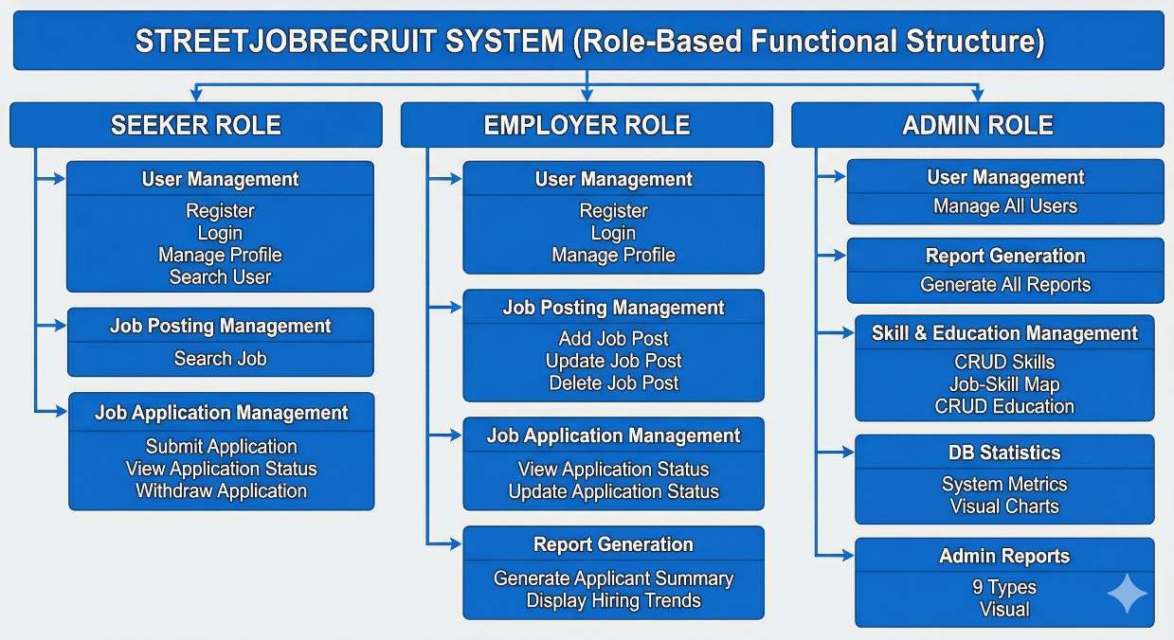

Figure 2.2.1 Structured Chart

# DESIGN

## Business Rules

1. **User Management Module**

**Identity Uniqueness**: Every user must register with a unique email and ID to prevent duplicate accounts and data confusion.

* **Role-Based Access**: Users must select a role—Job Seeker, Employer, or Administrator—upon registration, which strictly defines the features they can access.
* **Profile Integrity**: A profile must contain valid contact information and skills before a seeker can apply for jobs or an employer can drop a listing.

1. **Job Posting Management Module**

* **Ownership Lockdown**: Employers are only allowed to modify or delete job advertisements that they personally created.
* **Requirement Validation**: New job posts must include a title, description, and salary range to ensure job seekers have the full context before applying.
* **Listing Expiry**: Once a job is marked as "Filled" or is deleted by the employer, it must be removed from the public search view immediately.

1. **Job Application Management Module**

* **Single Submission**: To keep things fair and spam-free, a job seeker is limited to one application per specific job listing.
* **Status Authority**: Only the employer who posted the job has the permission to update the application status, moving candidates from "Pending" to "Shortlisted" or "Hired" .
* **Withdrawal Rights**: Job seekers can withdraw their applications at any time, which automatically updates the employer's applicant count and removes the record from active tracking.

1. **Report Generation Module**

* **Data Synchronization**: All analytical reports must be generated from live database data to ensure the statistics match the actual system activity.
* **Calculation Accuracy**: Complex calculations, such as the total number of applicants per job, must be performed automatically by the system to eliminate manual math errors.
* **Admin Oversight**: While employers can see their own hiring trends, only Administrators have the global authority to generate system-wide user activity reports.

## Flowchart

## System Flowchart

Figure 3.2.1.2 illustrates the operational flow of the system for each user role. Upon system initialization, the main menu is displayed, providing access to the Admin, Employer, Seeker, and Exit menus. If the Admin menu is selected, the user must undergo authentication via a unique username and password to access administrative functions. Similarly, Employers and Seekers are required to enter their credentials to access their respective functional modules. The Exit menu provides a secure termination of the system session.

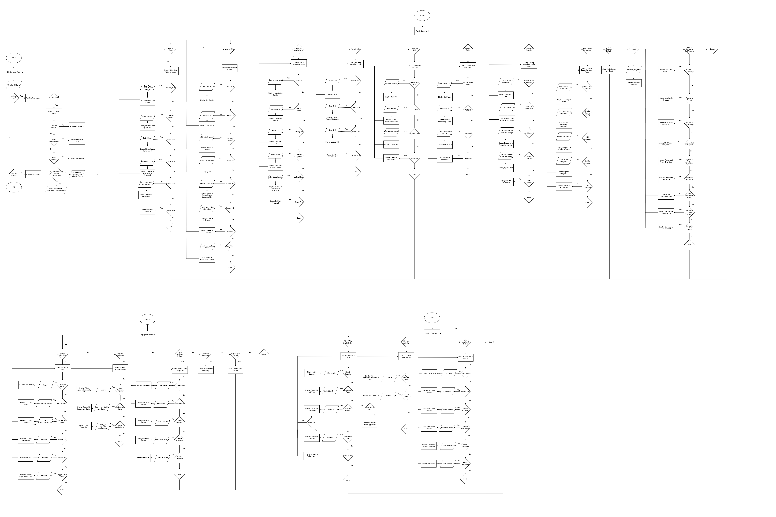

Figure 3.2.1.1 System Flowchart

## Seeker Flowchart

Figure 3.2 illustrates the operational flow within the Seeker Module of the system. Upon successful authentication, the user is directed to the Seeker Main Menu, which provides access to Profile Management, Job Search, and Application Tracking functionalities. The Profile Management section enables the user to update personal credentials and professional summaries, while the Job Search interface allows for the filtering and identification of available career opportunities. Additionally, the Application Tracking feature provides real-time visibility into the status of submitted applications. Selecting the logout option secures the user's data and returns the system to the initial authentication screen.

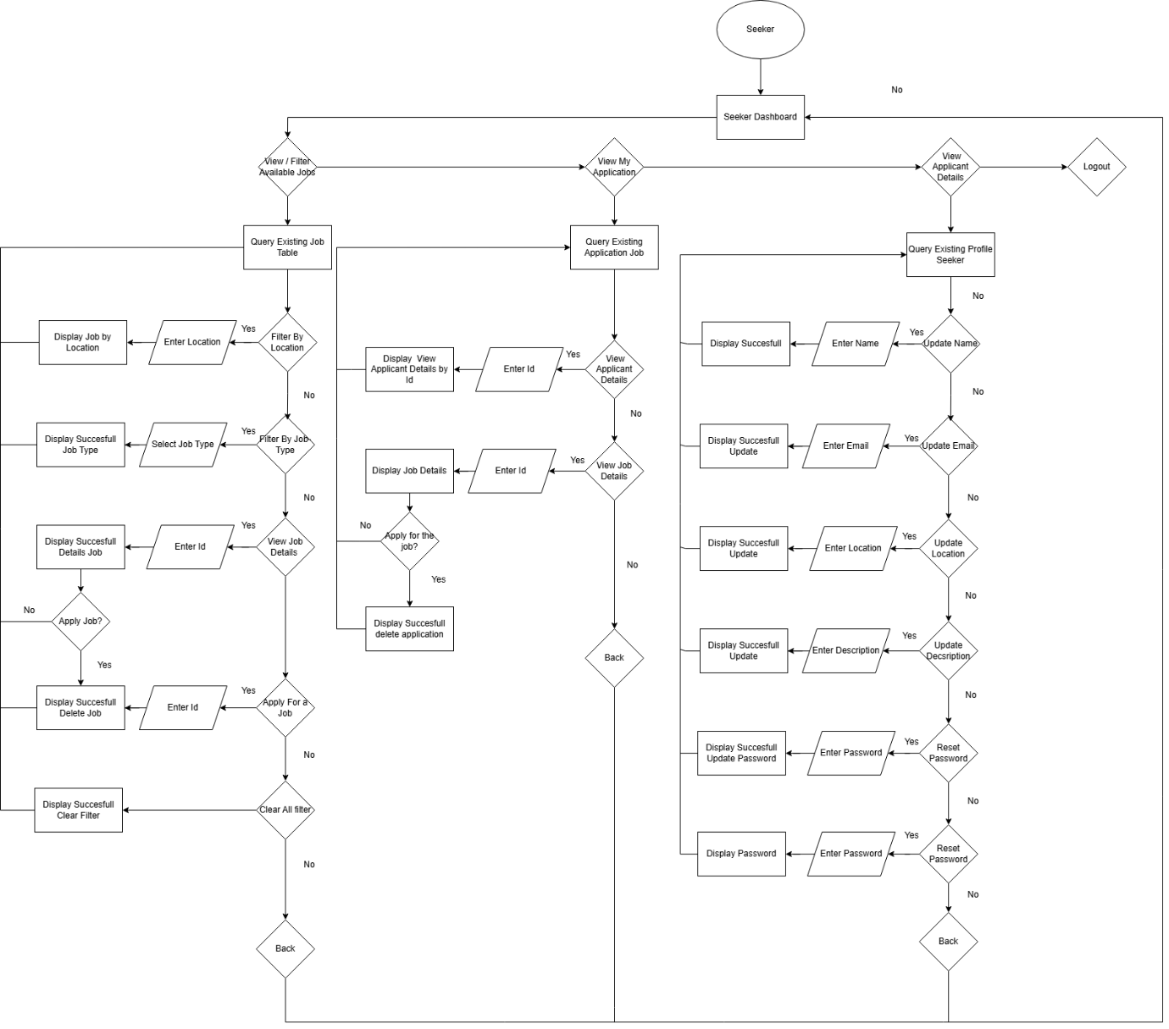

Figure 3.1.1.1 Seeker Flowchart

## Employer Flowchart

Figure 3.1.2.1 illustrates the operational flow of the Employer Module within the system. Following successful authentication, the user is directed to the Employer Main Menu, which facilitates the management of job vacancies and candidate applications. This module allows the employer to perform essential operations on job postings, including adding new listings, updating details, or deleting outdated advertisements. Furthermore, the Applicant Management interface enables the employer to review all submitted applications and update their hiring status in real-time. The logout functionality ensures the secure termination of the session and redirects the user to the main authentication screen.

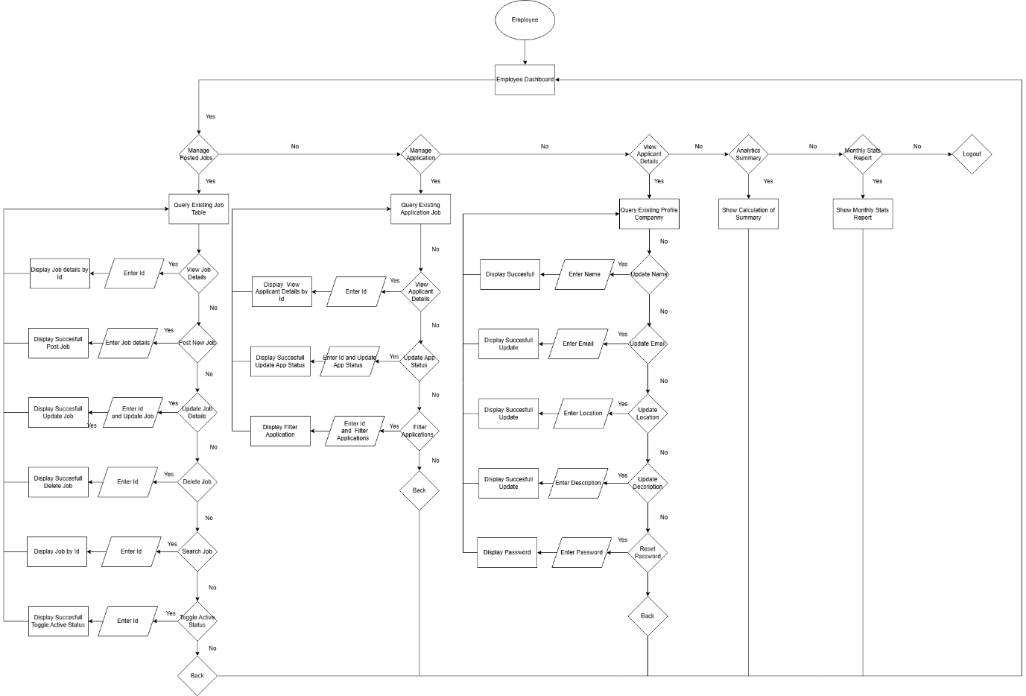

Figure 3.1.2.1 Employer Flowchart

## Admin Flowchart

Figure 4.3 illustrates the operational flow of the Admin Module within the system. After the administrator successfully logs in, the system displays the Admin Main Menu, which provides high-level oversight and maintenance of the platform. Key functionalities include User Management, where the administrator can monitor and search the database for all system accounts to ensure data integrity. Additionally, the Report Generation interface facilitates the creation of comprehensive analytical summaries regarding system activity, user statistics, and recruitment trends. Selecting the logout option secures the administrative interface and returns the system to the initial login page.

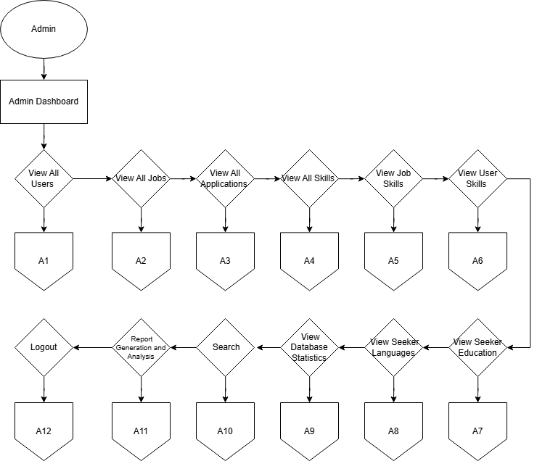

Figure 3.1.3.1Admin Menu

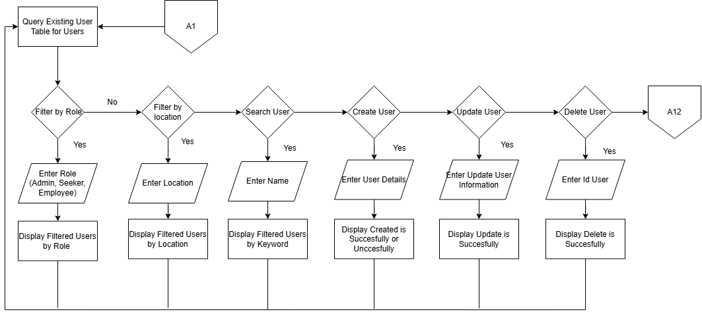

Figure 3.1.3.2 Admin View All Users

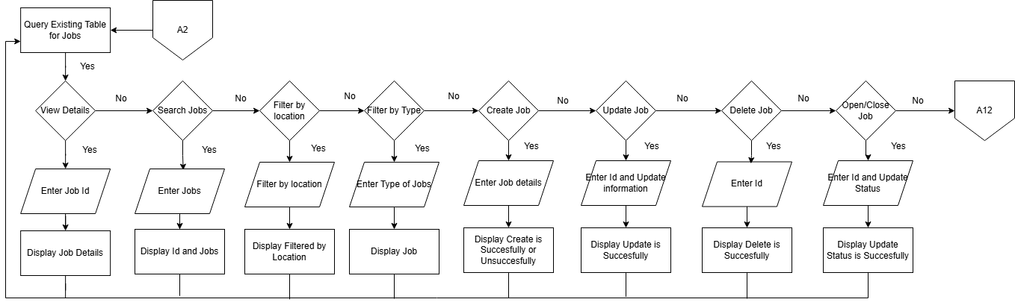

Figure 3.1.3.3 Admin View All Jobs

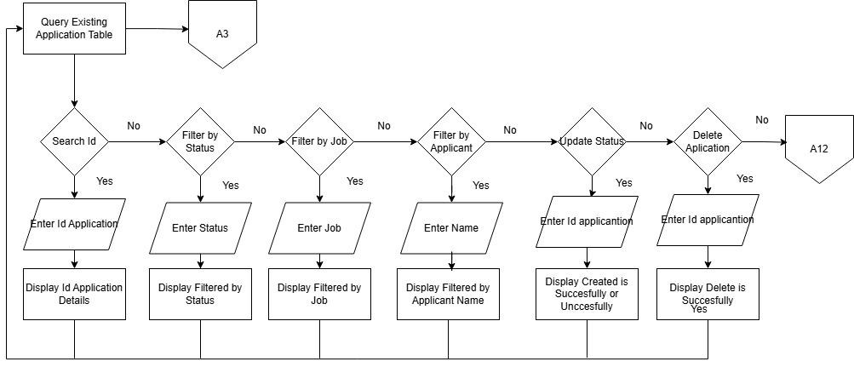

Figure 3.1.3.4 Admin View All Applications

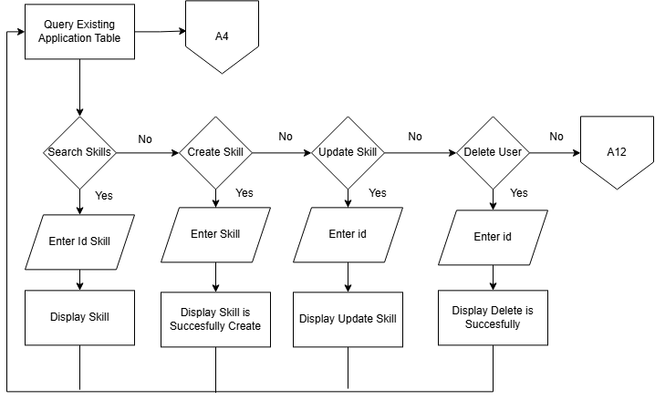

Figure 3.1.3.5 Admin View All Skills

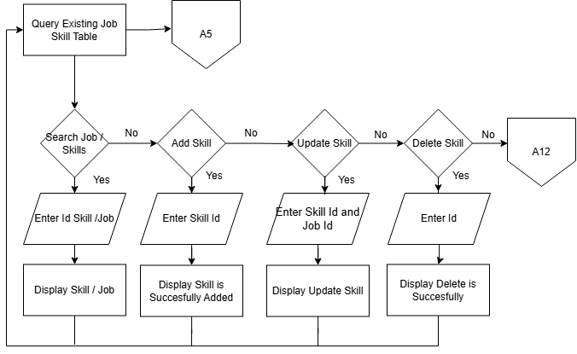

Figure 3.1.3.6 Admin View Job Skills

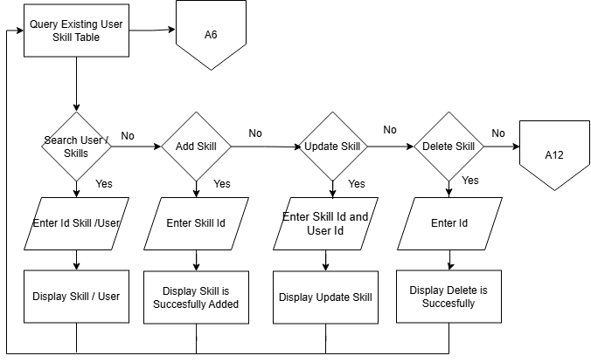

Figure 3.1.3.7 Admin View User Skills

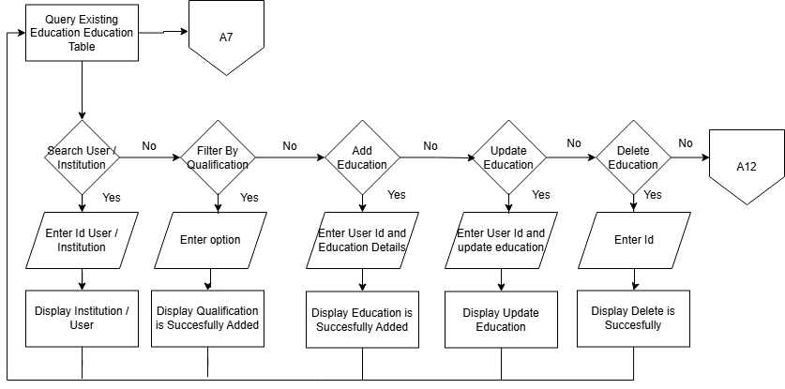

Figure 3.1.3.8 Admin View Seeker Education

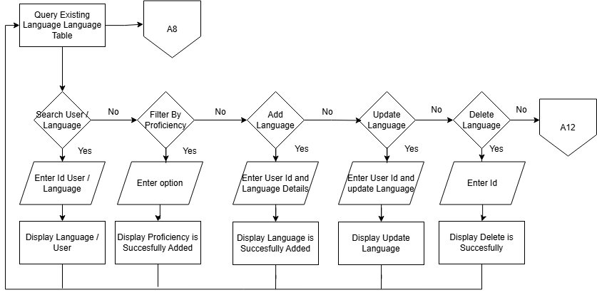

Figure 3.1.3.9 Admin View Seeker Languages

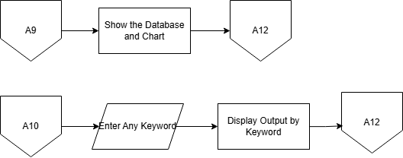

Figure 3.1.3.10 Admin View Database Statistics and Search

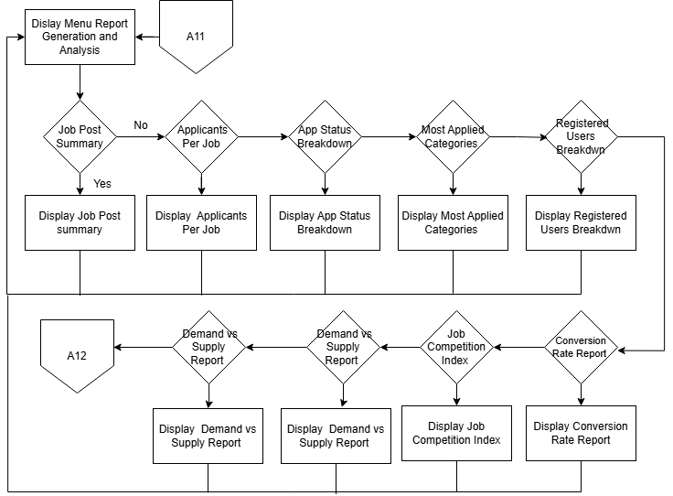

Figure 3.1.3.11 Admin Report Generation

## ERD

Figure 3.3.1 illustrates the database architecture for the StreetJobRecruit System. The diagram defines the entities, attributes, and the relational constraints that ensure data integrity across the platform.

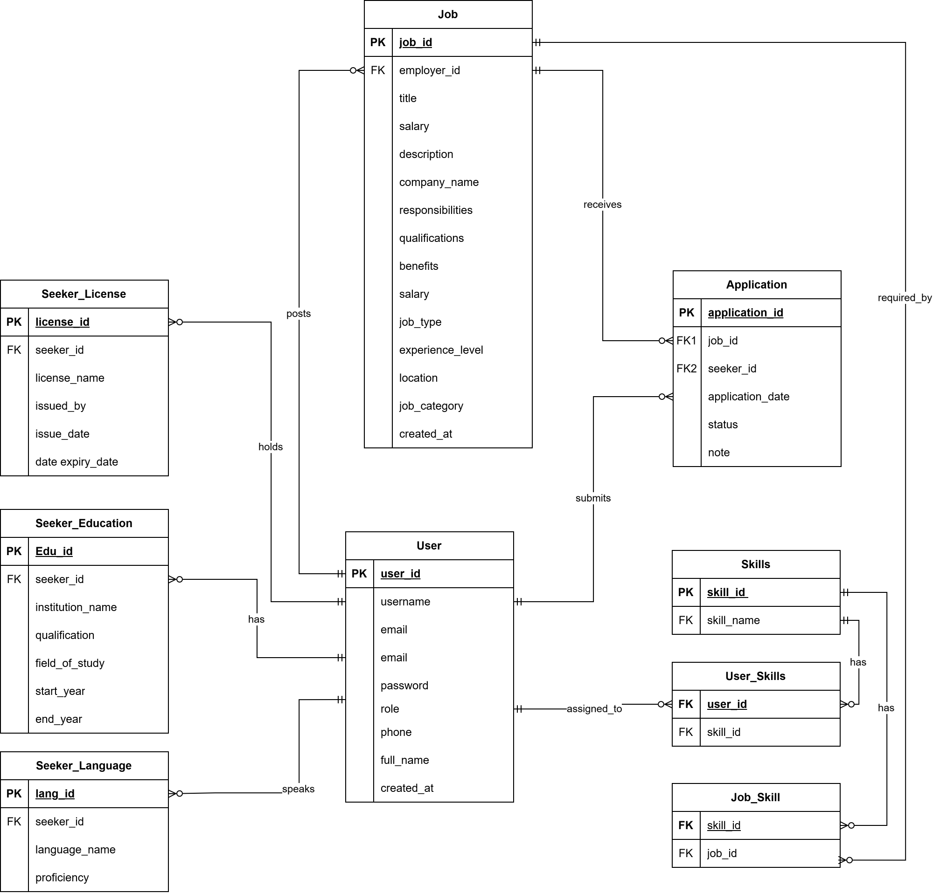

Figure 3.3.1 ERD

## Data Normalization

The data normalization process for the StreetJobRecruit System is a systematic approach to organizing the database to minimize redundancy and eliminate data anomalies. By refining the structure into smaller, logically related tables, the system ensures that every piece of data is stored in only one place, thereby improving data integrity and query performance. The process follows a progression from an unnormalized state to the Third Normal Form (3NF), which is the standard for professional-grade relational databases.

|  |  |  |
| --- | --- | --- |
| Stage | Action Taken | Result for StreetJobRecruit System |
| UNF (Unnormalized Form) | Collection of all data (User info, Job details, Skills, Education) in one large table with repeating groups. | High redundancy: updating an employer's email requires changing every row containing their job posts. |
| 1NF (First Normal Form) | Removed repeating groups and ensured all attributes contain atomic (single) values. Defined Primary Keys for each record. | Attributes like "Skills" (e.g., 'Java, SQL') are broken down into individual records so each cell contains only one value. |
| 2NF (Second Normal Form) | Removed partial functional dependencies by ensuring all non-key attributes depend on the whole Primary Key. | Created separate tables for **users**, **jobs**, and **applications**. A job title now only depends on the job_id, not on the user details. |
| 3NF (Third Normal Form) | Eliminated transitive dependencies by moving non-key attributes that depend on other non-key attributes into specialized tables. | Extracted details into **skills**, **seeker_education**, **seeker_language**, and **seeker_license**. This ensures every field depends ONLY on the Primary Key. |

Table 3.4.1 Data Normalization

## Data Dictionary

|  |  |  |  |  |
| --- | --- | --- | --- | --- |
| Field Name | Data Type | Length | Constraint | Description |
| user_id | Integer | 10 | Primary Key | Unique identifier for each user. |
| username | Varchar | 50 | Unique, Not Null | The login name used for authentication. |
| email | Varchar | 100 | Unique, Not Null | The user's primary contact email address. |
| password | Varchar | 8 | Not Null | Encrypted password string for security. |
| role | Varchar | 15 | Not Null | Defines user type (Admin, Employer, Seeker). |

Table 3.5.1 User

|  |  |  |  |  |
| --- | --- | --- | --- | --- |
| Field Name | Data Type | Length | Constraint | Description |
| job_id | Integer | 10 | Primary Key | Unique identifier for the job post. |
| employer_id | Integer | 10 | Foreign Key | Links the job to the specific User (Employer). |
| job_title | Varchar | 100 | Not Null | The official name of the position. |
| salary | Decimal | 10,2 | Optional | The offered compensation amount. |
| job_location | Varchar | 100 | Not Null | The geographic location of the role. |

Table 3.5.2 Job

|  |  |  |  |  |
| --- | --- | --- | --- | --- |
| Field Name | Data Type | Length | Constraint | Description |
| application_id | Integer | 10 | Primary Key | Unique identifier for the application record. |
| seeker_id | Integer | 10 | Foreign Key | Links to the User (Seeker) applying. |
| job_id | Integer | 10 | Foreign Key | Links to the specific Job being applied for. |
| apply_date | Date | - | Not Null | The timestamp of when the application was sent. |
| status | Varchar | 20 | Default: 'Pending' | Current state (Pending, Shortlisted, Hired). |

Table 3.5.3 Application

|  |  |  |  |  |
| --- | --- | --- | --- | --- |
| Field Name | Data Type | Length | Constraint | Description |
| user_id | Integer | 11 | Primary Key, Foreign Key | ID of the seeker possessing the skill. |
| skill_id | Integer | 11 | Primary Key, Foreign Key | ID of the skill associated with the user. |

Table 3.5.4 User Skill

|  |  |  |  |  |
| --- | --- | --- | --- | --- |
| Field Name | Data Type | Length | Constraint | Description |
| job_id | Integer | 11 | Primary Key, Foreign Key | ID of the job listing. |
| skill_id | Integer | 11 | Primary Key, Foreign Key | ID of the skill required for the job. |

Table 3.5.5 Job Skill

|  |  |  |  |  |
| --- | --- | --- | --- | --- |
| Field Name | Data Type | Length | Constraint | Description |
| edu_id | Integer | 11 | Primary Key, Auto-Increment | Unique identifier for the education record. |
| seeker_id | Integer | 11 | Foreign Key | ID of the seeker this record belongs to. |
| qualification | Varchar | 100 | Not Null | The level of education attained (e.g., Degree, SPM). |

Table 3.5.6 Seeker Education

|  |  |  |  |  |
| --- | --- | --- | --- | --- |
| Field Name | Data Type | Length | Constraint | Description |
| lang_id | Integer | 11 | Primary Key, Auto-Increment | Unique identifier for the language record. |
| language_name | Varchar | 10 | Not Null | The name of the language. |
| proficiency | Enum | - | Not Null | Level of command ('Basic', 'Fluent', 'Native'). |
| Field Name | Data Type | Length | Constraint | Description |
| license_id | Integer | 11 | Primary Key, Auto-Increment | Unique identifier for the license record. |
| seeker_id | Integer | 11 | Foreign Key | ID of the seeker holding the license. |
| license_name | Varchar | 100 | Not Null | The title of the professional license or certificate. |

Table 3.5.7 Seeker Language

|  |  |  |  |  |
| --- | --- | --- | --- | --- |
| Field Name | Data Type | Length | Constraint | Description |
| license_id | Integer | 11 | Primary Key, Auto-Increment | Unique identifier for the license record. |
| seeker_id | Integer | 11 | Foreign Key | ID of the seeker holding the license. |
| license_name | Varchar | 100 | Not Null | The title of the professional license or certificate. |

Table 3.5.8 Seeker License

## Interface Design

## Menu Login

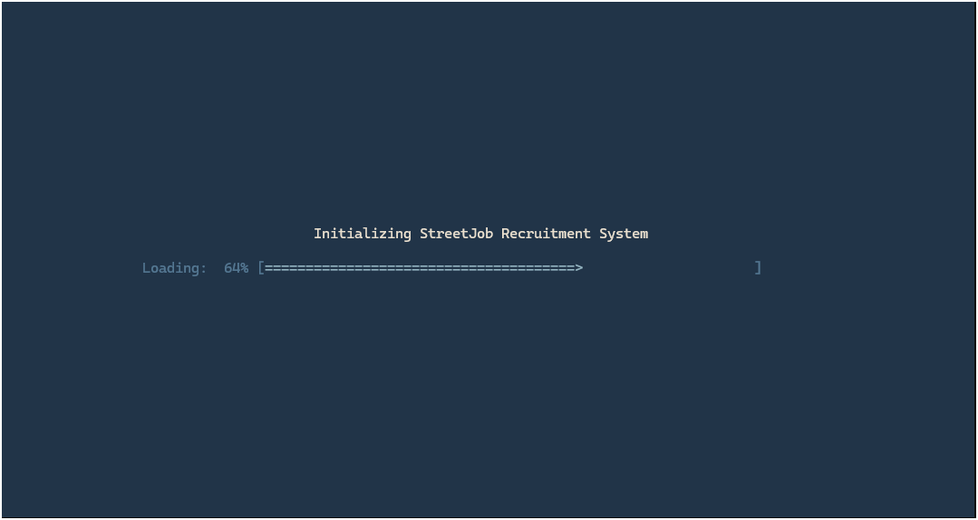

Figure 3.6.1.1 Loading Menu Interface



Figure 3.6.1.2 Menu Welcome

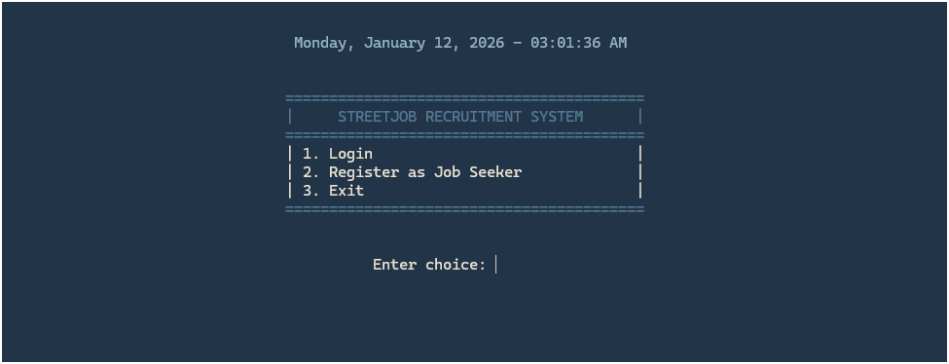

Figure 3.6.1.3 Menu

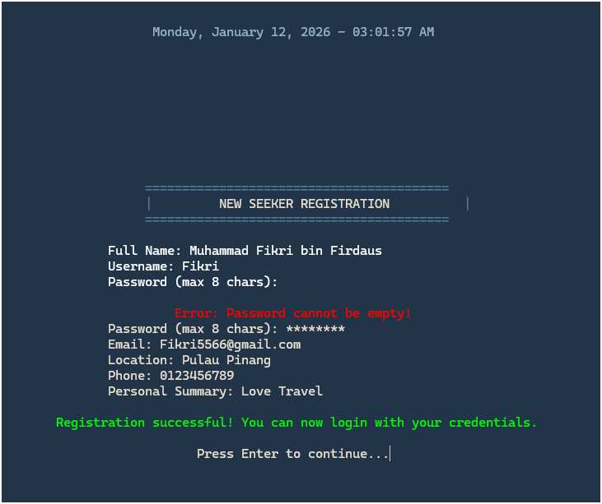

Figure 3.6.1.4 Register User

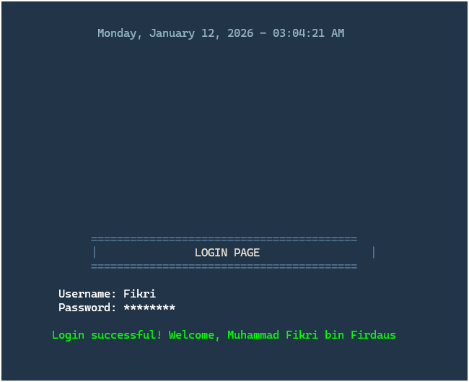

Figure 3.6.1.5 Login Page

## Seeker Interface

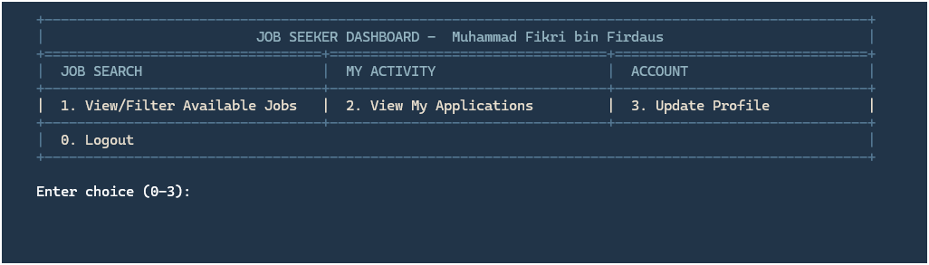

**Figure 3.6.2.1 Seeker Menu**

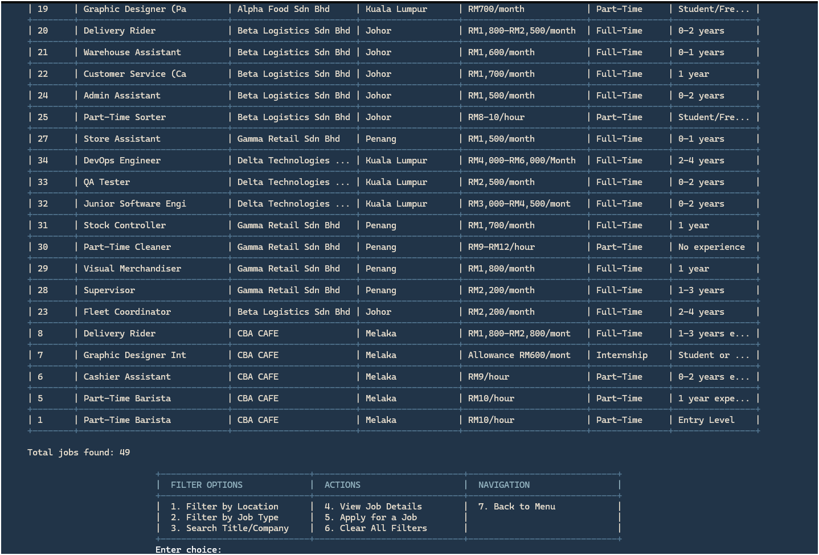

Figure 3.6.2.2 Seeker View/Filter Available Jobs

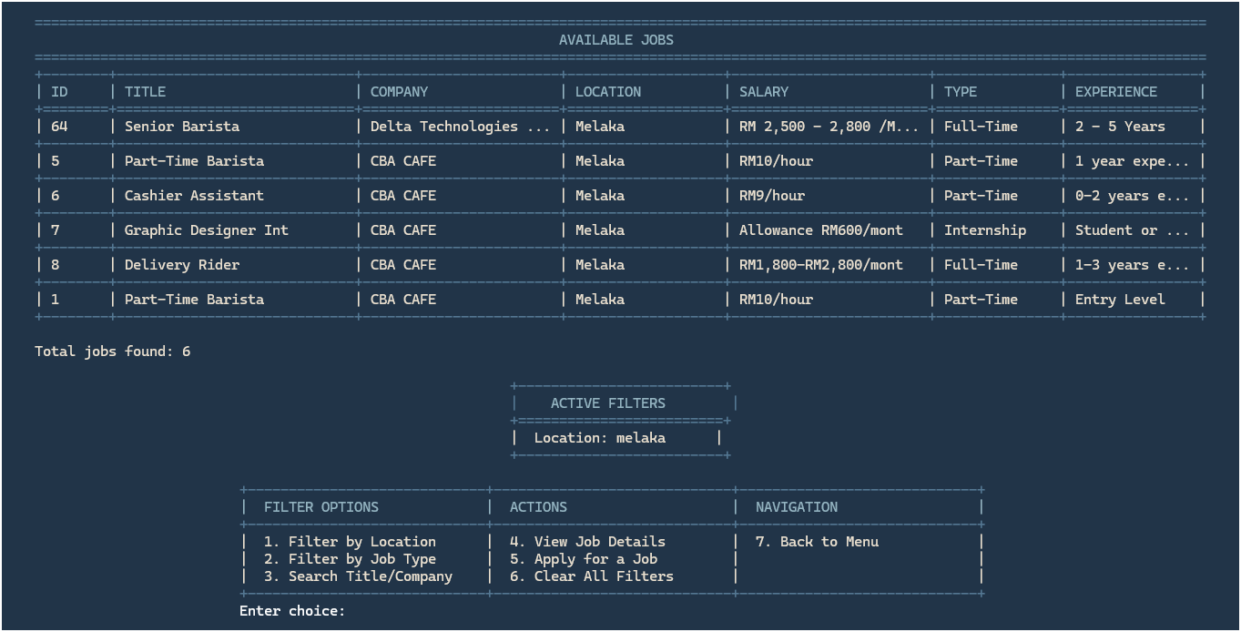

Figure 3.6.2.3 Seeker Filter by Location

Filter by job type and search title / company will not be show since it has same function with Figure 3.6.1.3 Seeker Filter by Location.

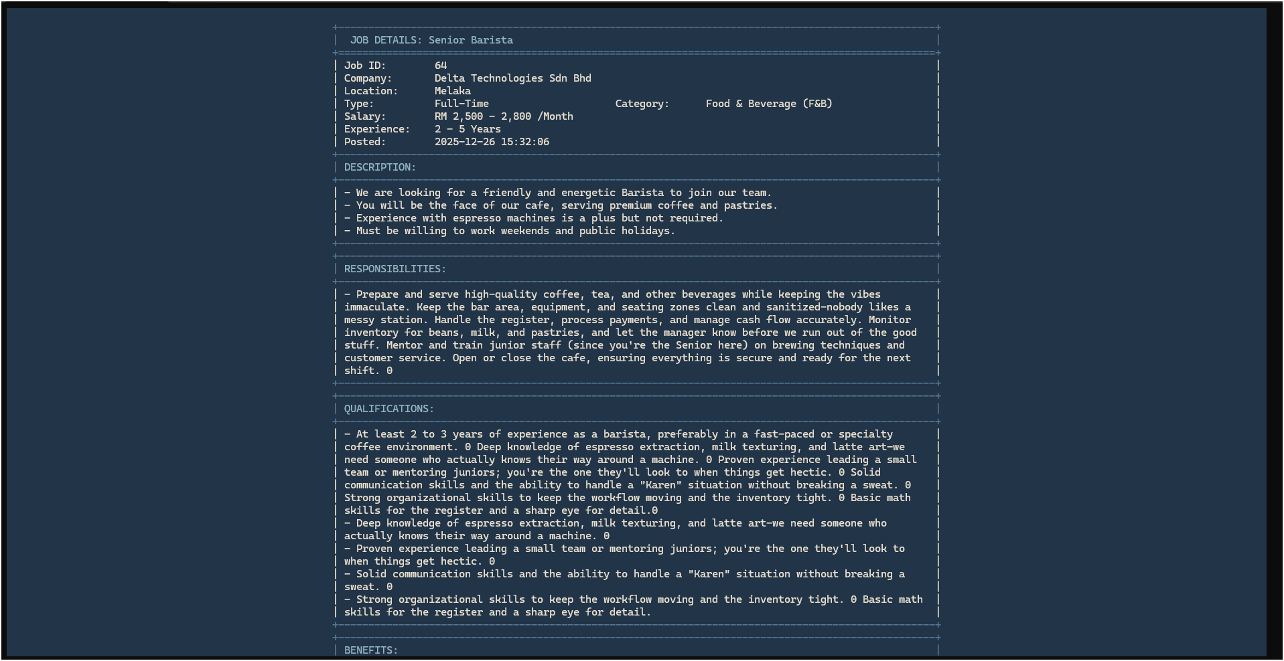

Figure 3.6.2.4 Seeker View Job Details

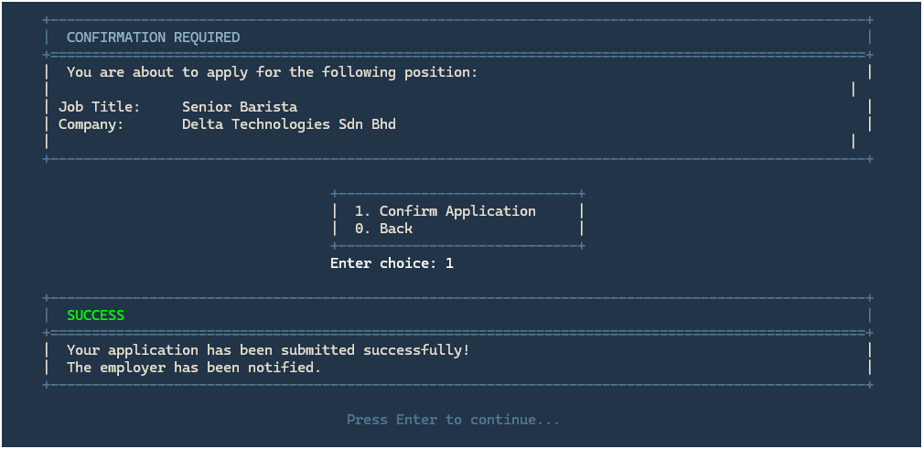

Figure 3.6.2.5 Seeker Apply for a Job

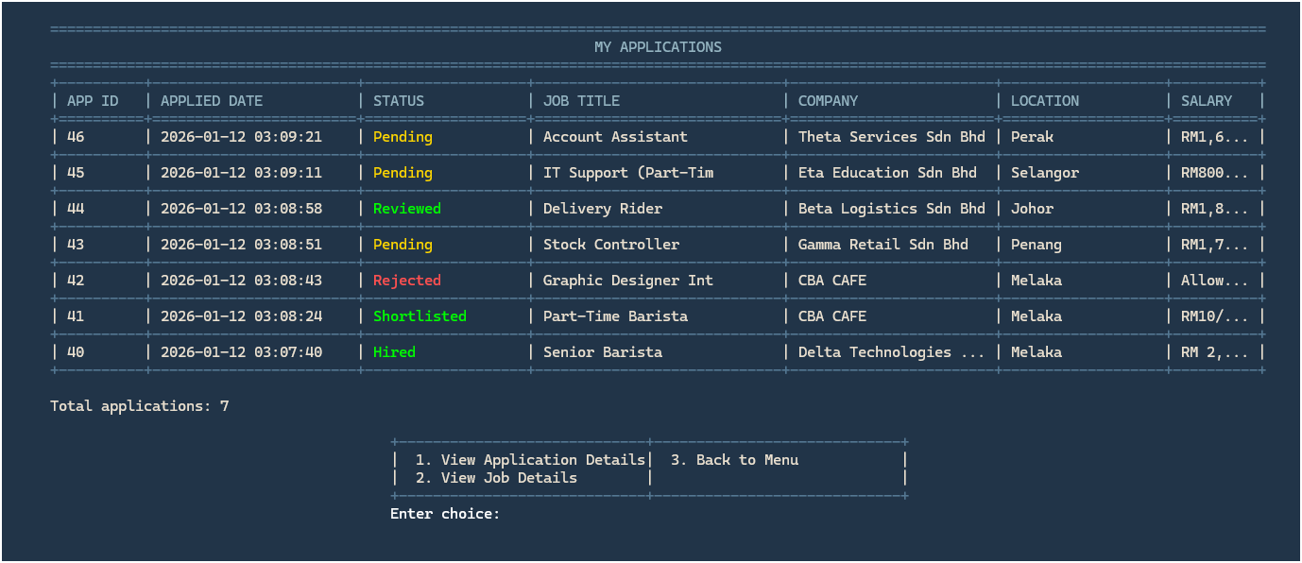

Figure 3.6.2.6 Seeker View My Applications

View Job Details have same function as Figure 3.6.1.4 Seeker View Job Details.

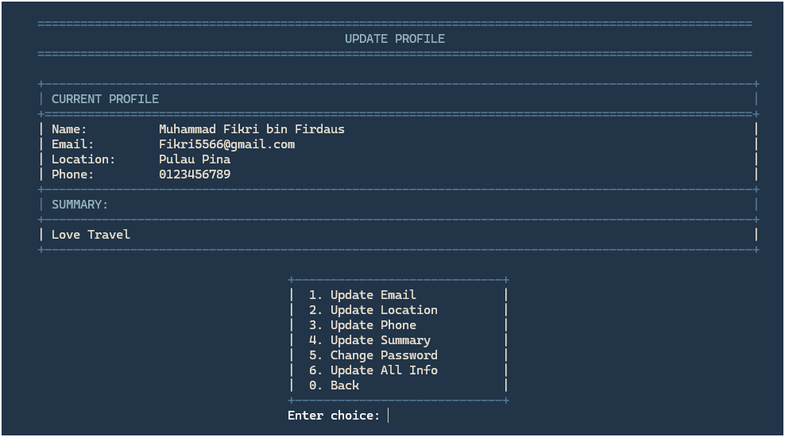

Figure 3.6.2.7 Seeker Update Profile

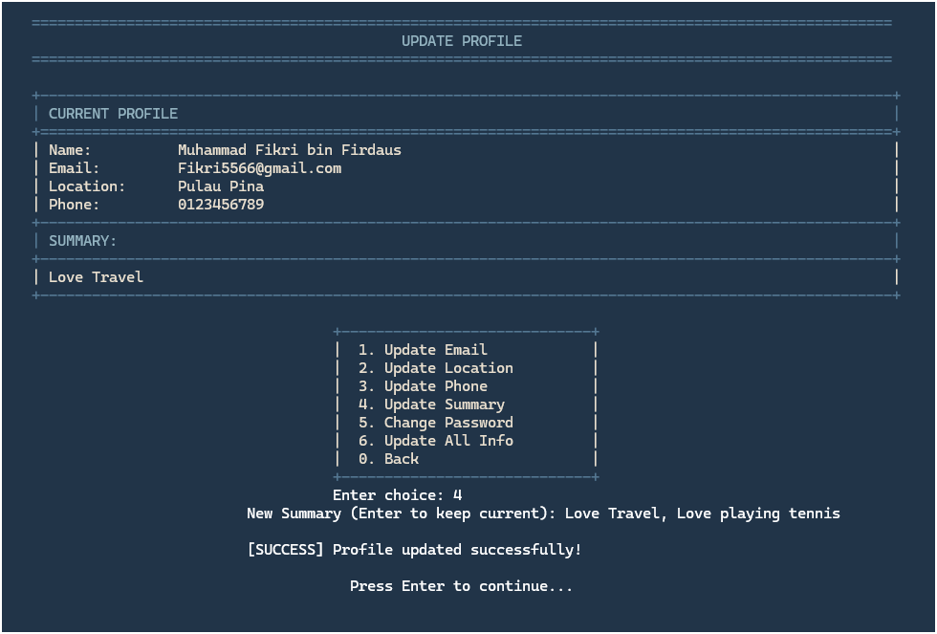

Figure 3.6.2.8 Seeker Update Summary

Update Email, location, phone, summary, all info, change password is same function as Figure 3.6.1.8 Seeker Update Summary.

## Employer Interface

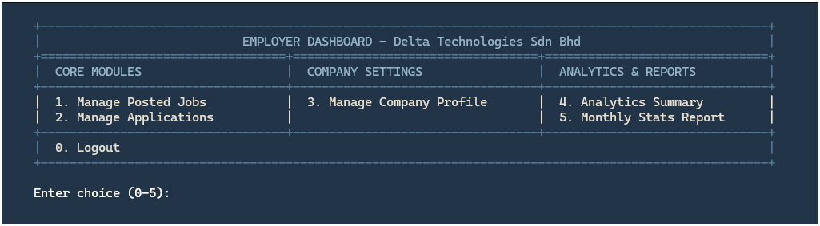

Figure 3.6.3.1 Employer Menu

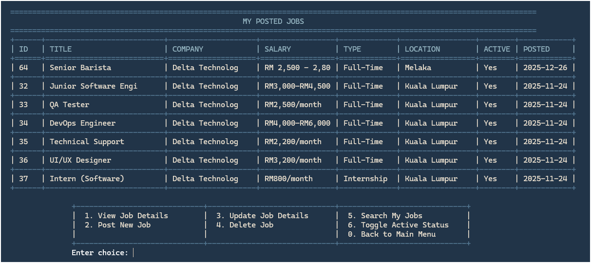

Figure 3.6.3.2 Employer Manage Posted Jobs

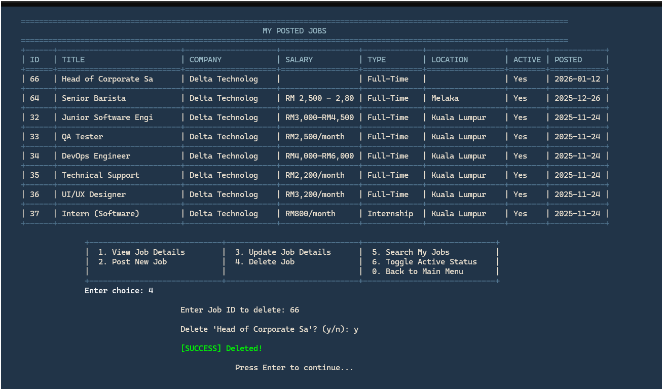

Figure 3.6.3.3 Employer Delete Job

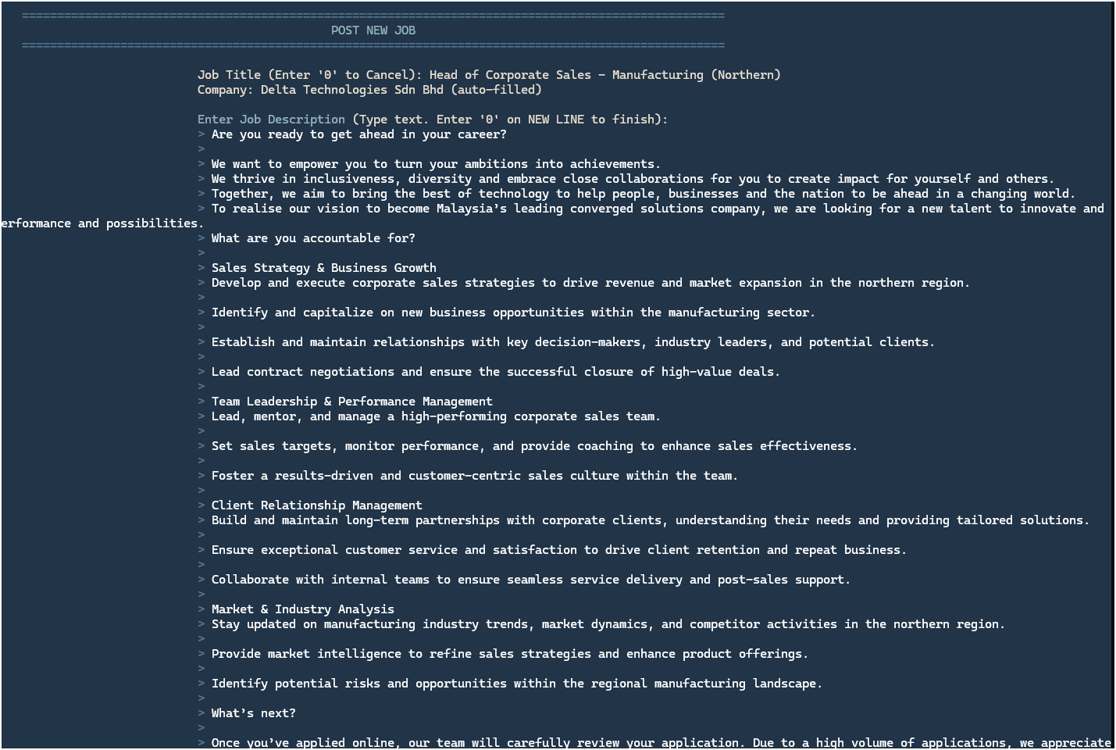

Figure 3.6.3.4 Employer Post New Job

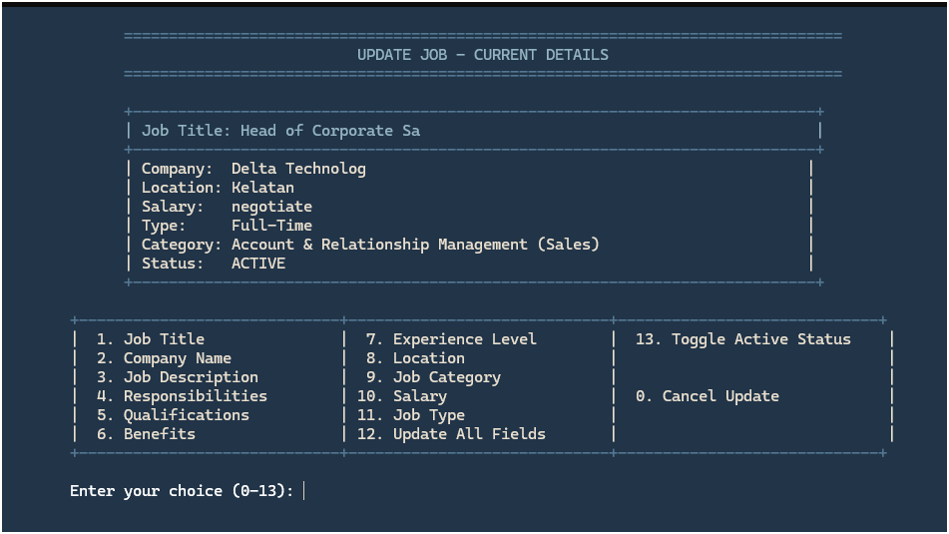

Figure 3.6.3.5 Seeker Update Job

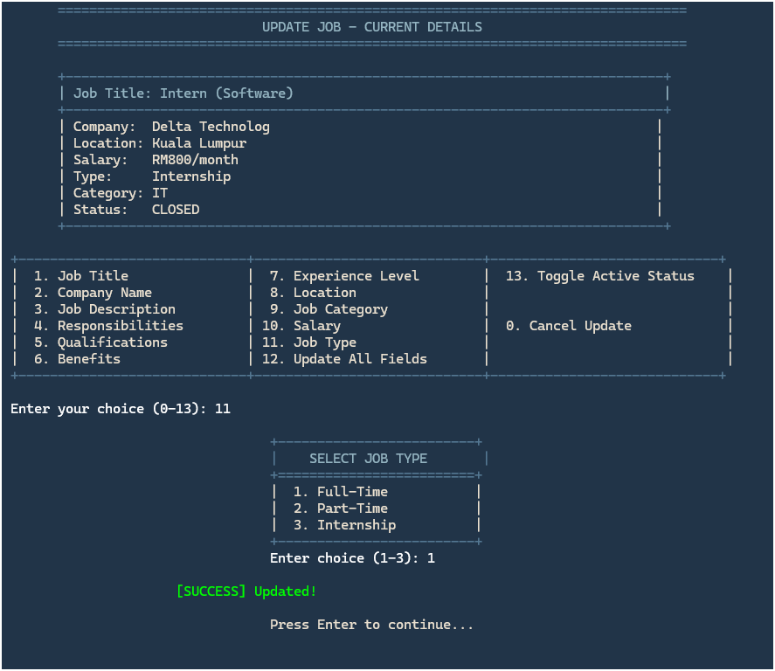

Figure 3.6.3.6 Employer Update Job Type

Job category has same function as Figure 3.6.2.6 Employer Update Job Type.

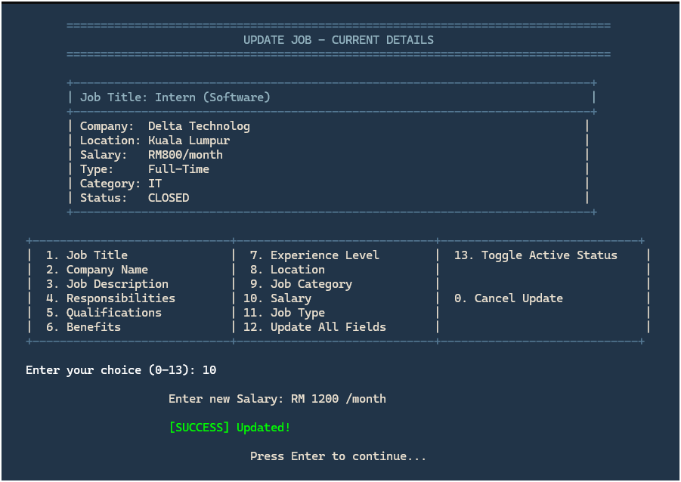

Figure 3.6.3.7 Employer Update Salary

Job title, company name, job description, responsibilities, qualifications, benefits, experience level, update all fields is same function as Figure 3.6.2.7 Employer Update Salary.

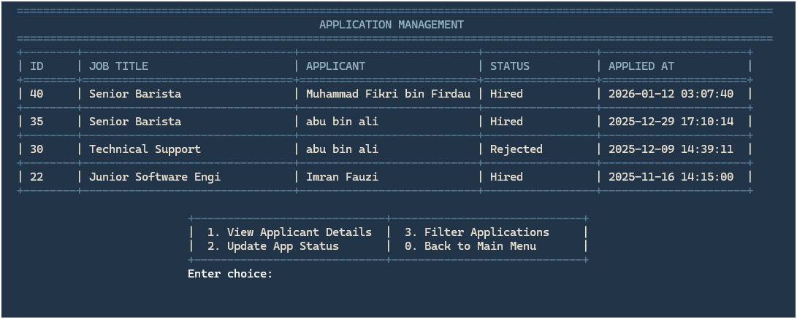

Figure 3.6.3.8 Employer Manage Applications

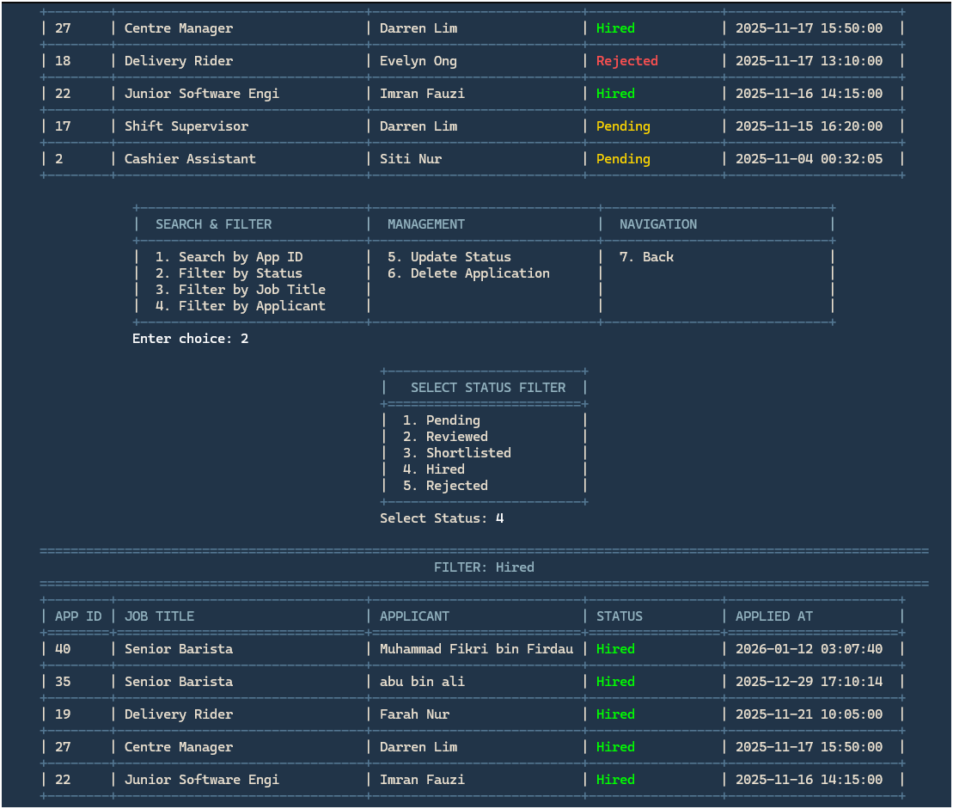

Figure 3.6.3.9 Employer Filter by Status

Search by app id, filter by job title, applicant is same as Figure 3.6.2.9 Employer Filter by Status.

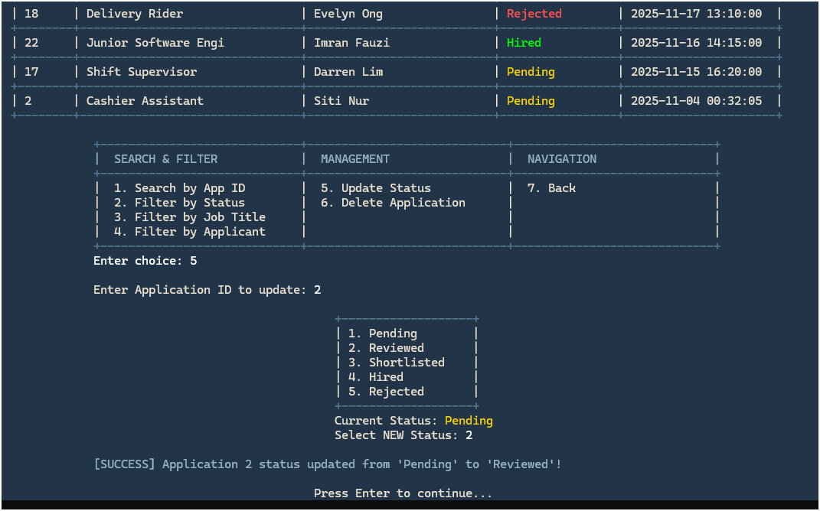

Figure 3.6.3.10 Employer Update Status

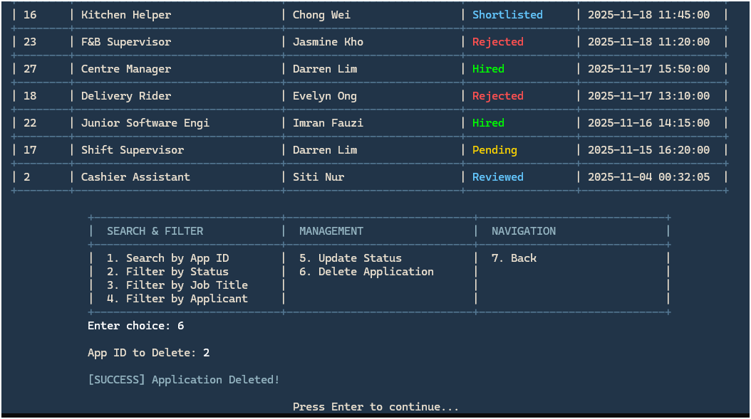

Figure 3.6.3.11 Employer Delete Application

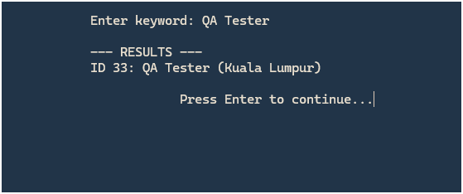

Figure 3.6.3.12 Employer Search My Jobs

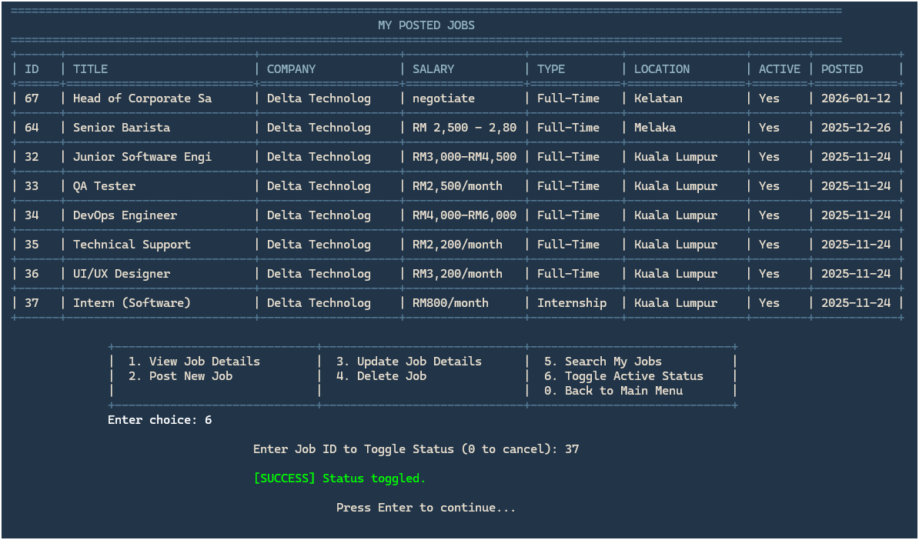

Figure 3.6.3.13 Employer Active Toggle Status

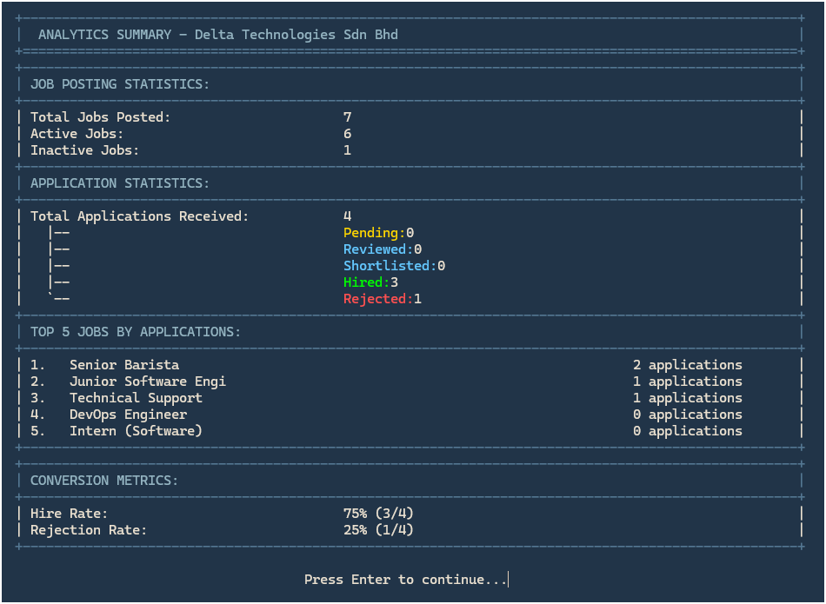

Figure 3.6.3.14 Employer Analytics Summary

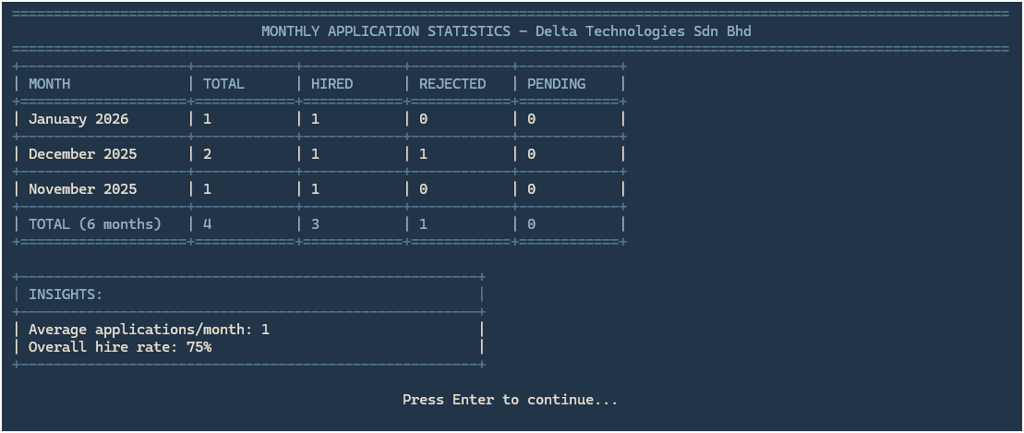

Figure 3.6.3.15 Employer Monthly Stats Report

## Admin Interface

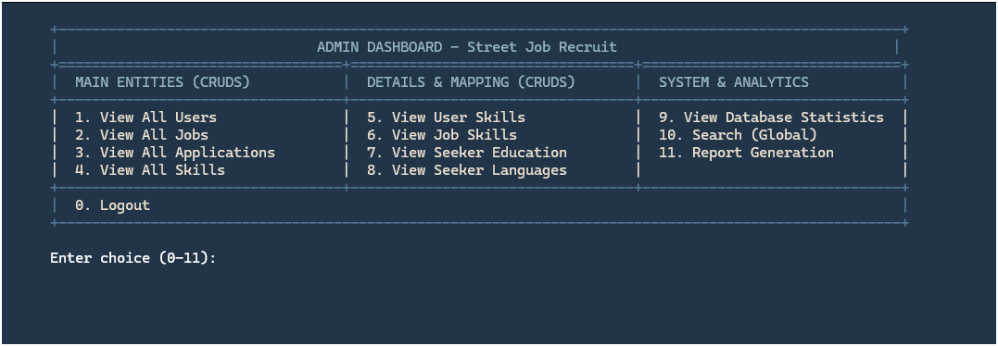

Figure 3.6.4.1 Admin Menu

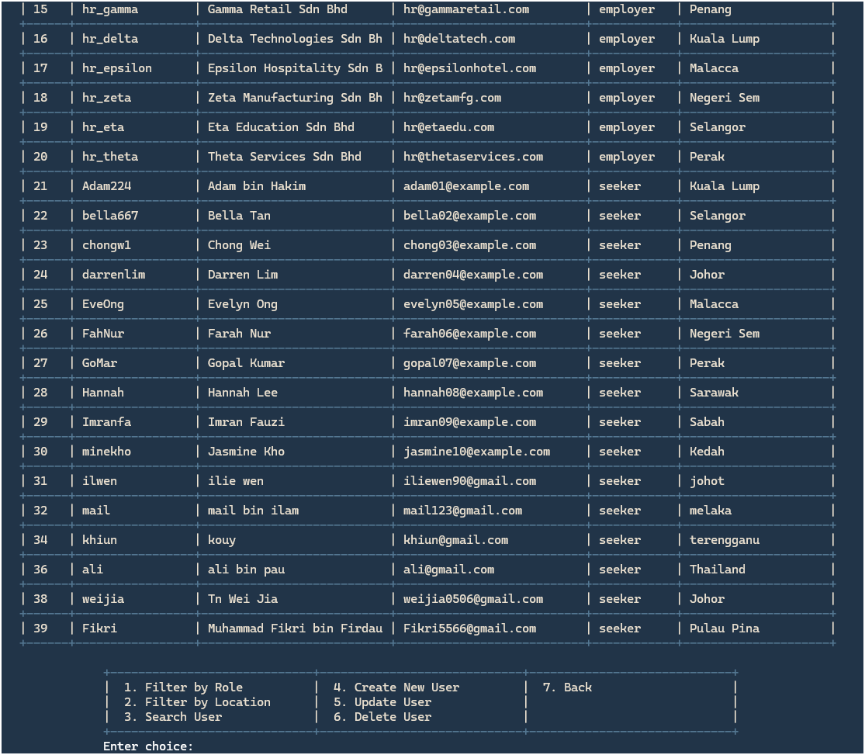

Figure 3.6.4.2 View All Users

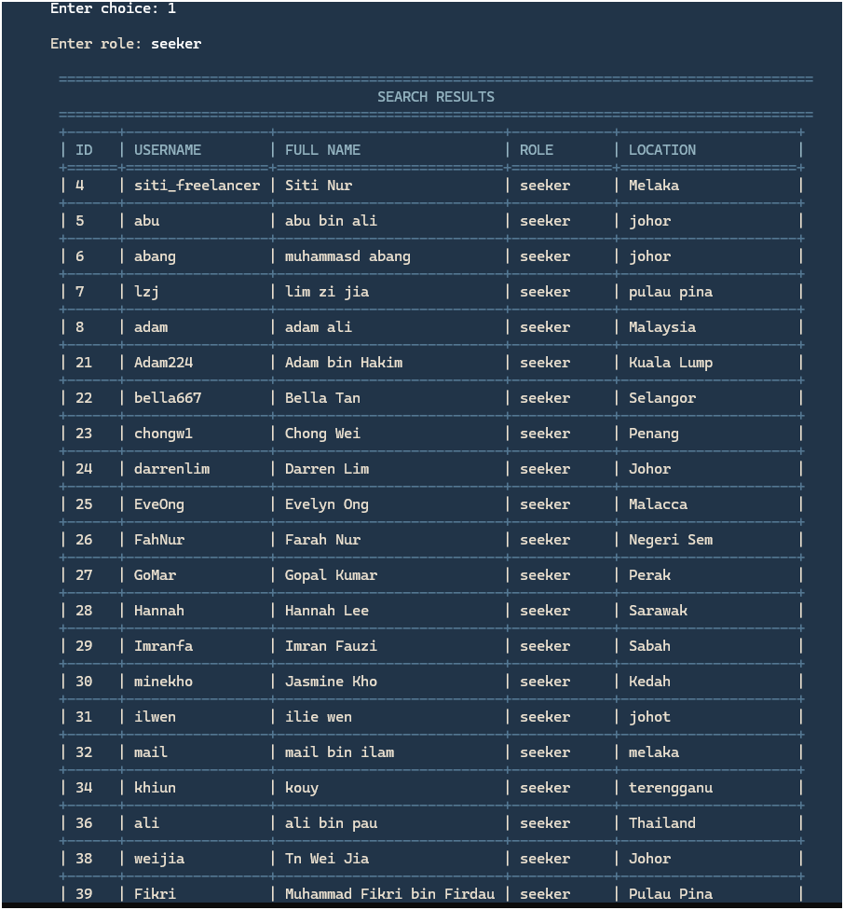

Figure 3.6.4.3 Admin Filter by Role

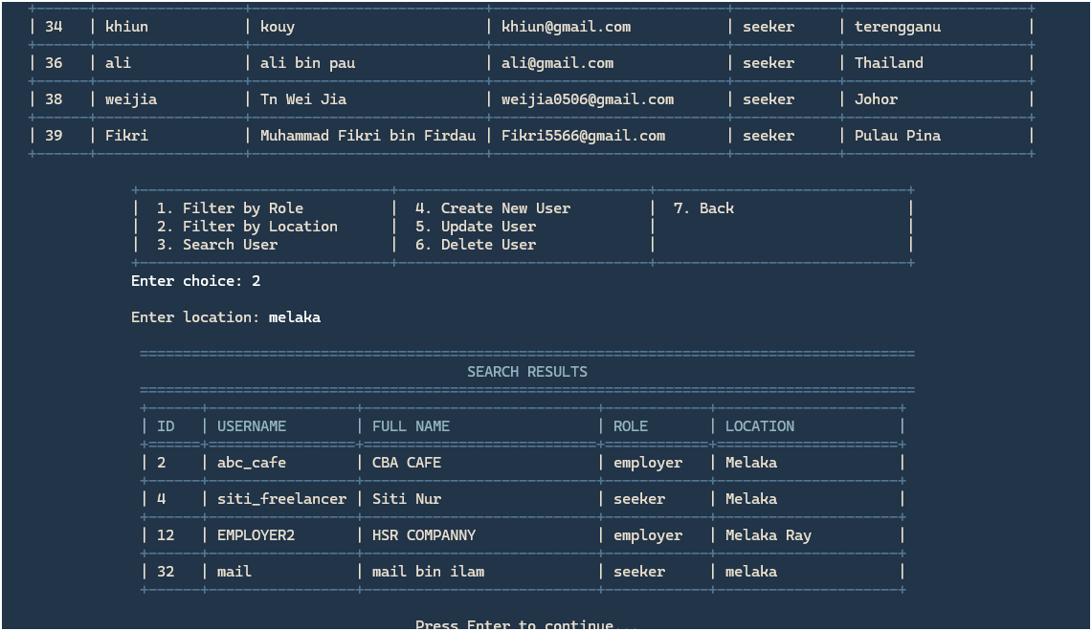

Figure 3.6.4.4 Admin Filter By Location

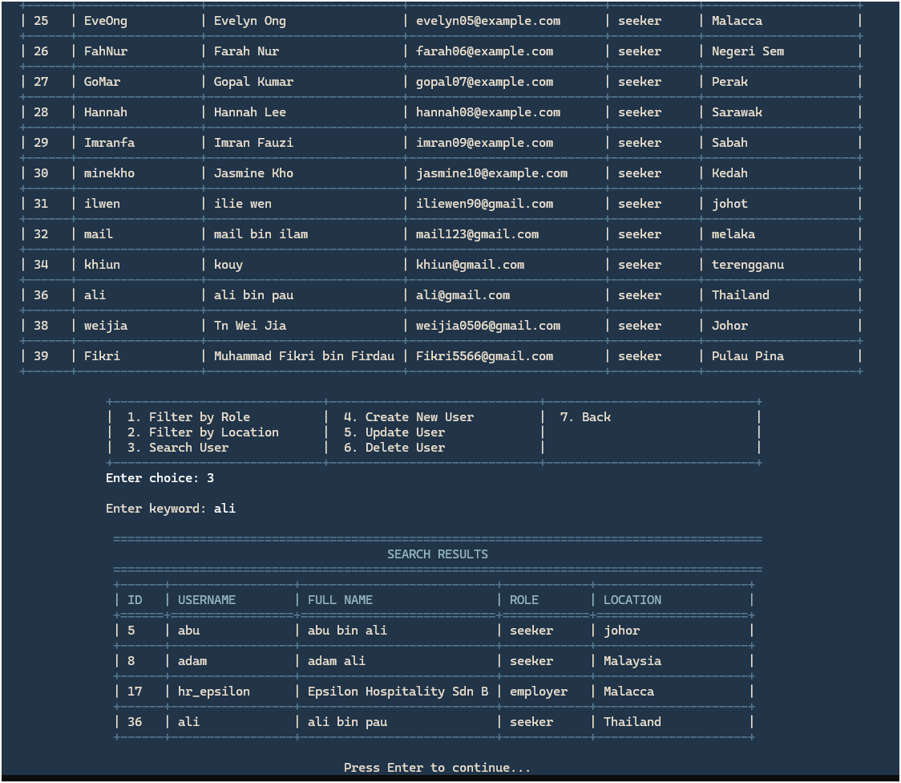

**Figure 3.6.4.5 Admin Search**

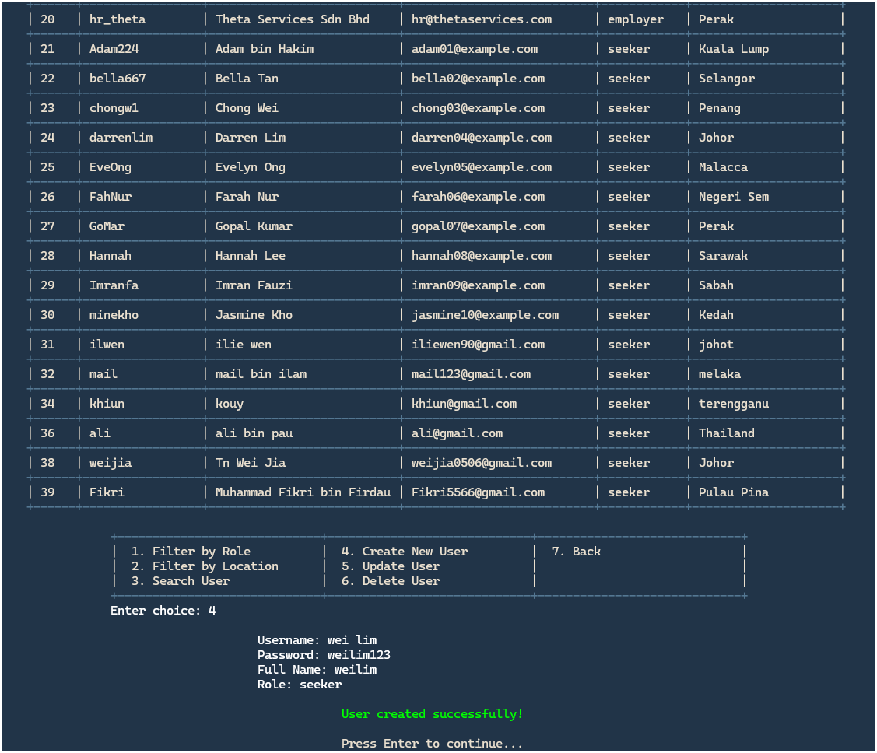

Figure 3.6.4.6 Admin Create User

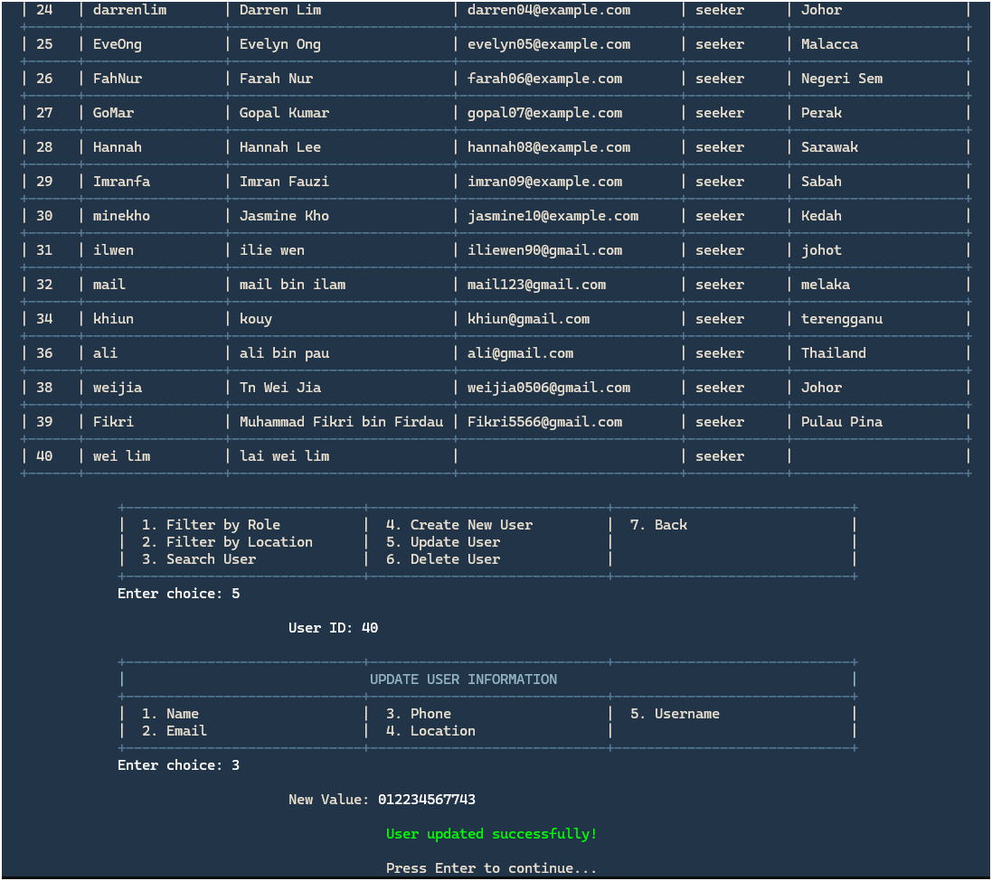

Figure 3.6.4.7 Admin Update User

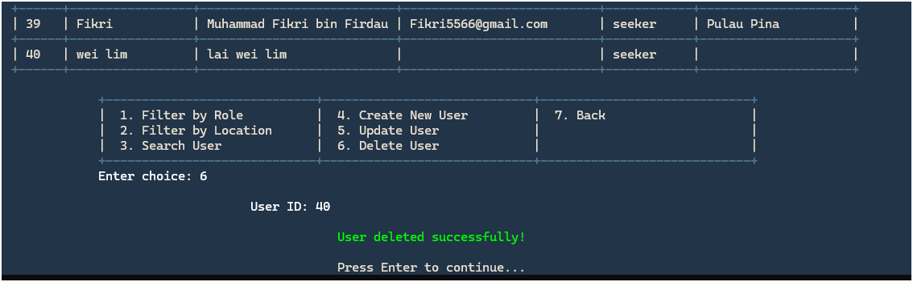

Figure 3.6.4.8 Admin Delete User

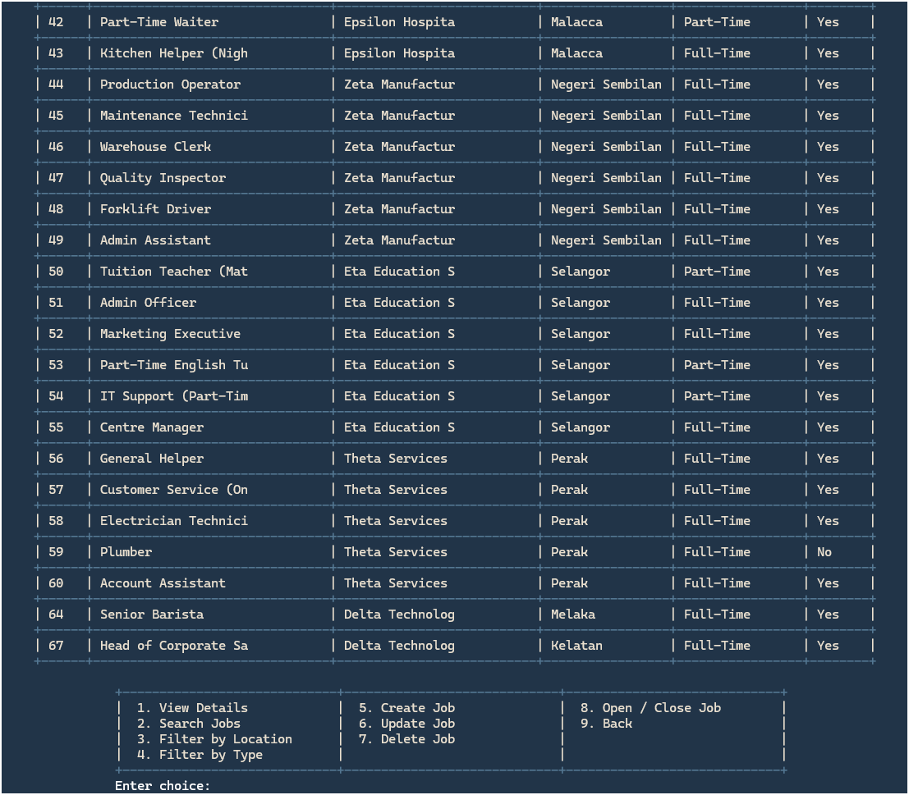

Figure 3.6.4.9 Admin View All Jobs

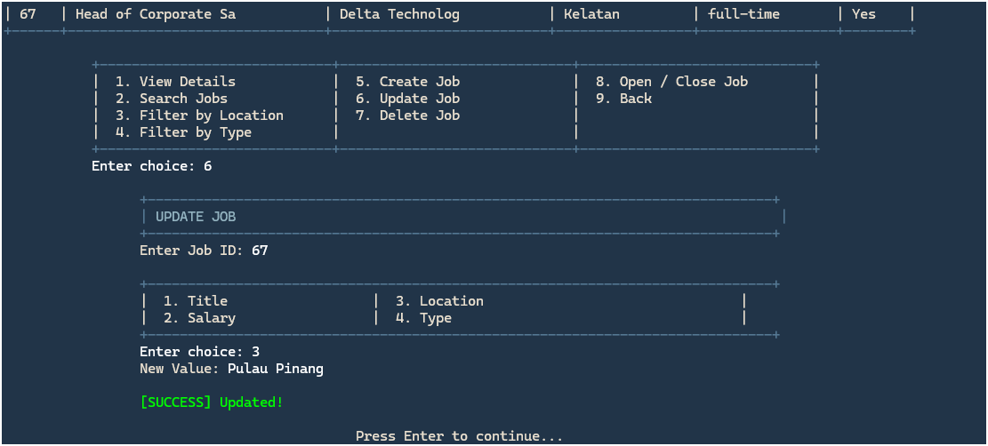

Figure 3.6.4.10 Admin Update Job

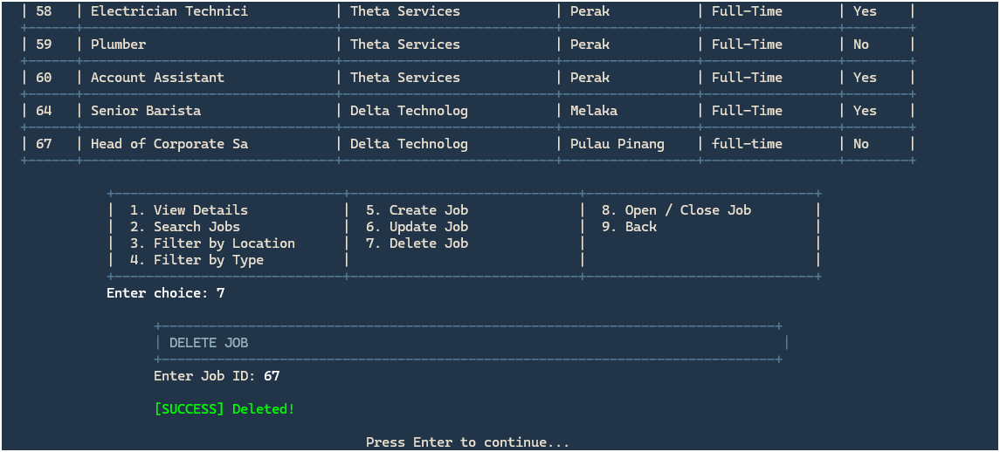

Figure 3.6.4.11 Admin Delete Job

* View details are the same as Figure 3.6.2.4 Seeker View Job Details,
* search job same as Figure 3.6.4.12 Admin Search App Id
* filter by location, type is same as Figure 3.6.2.3 Seeker Filter by Location.
* Create job is same function as Figure 3.6.3.4 Employer Post New Job.

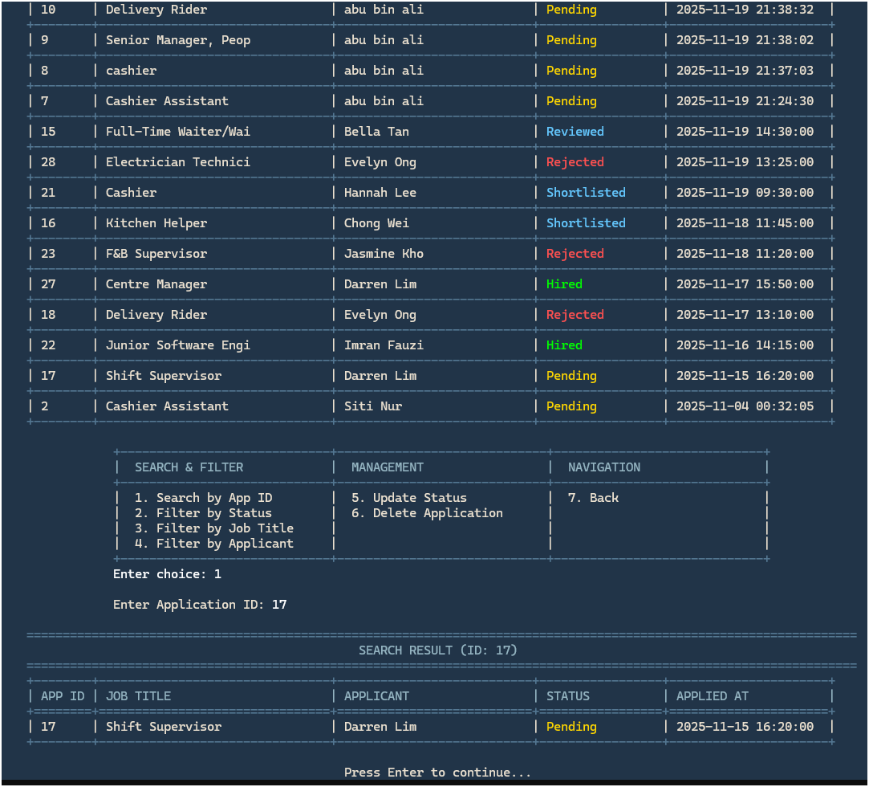

Figure 3.6.4.12 Admin Search App Id

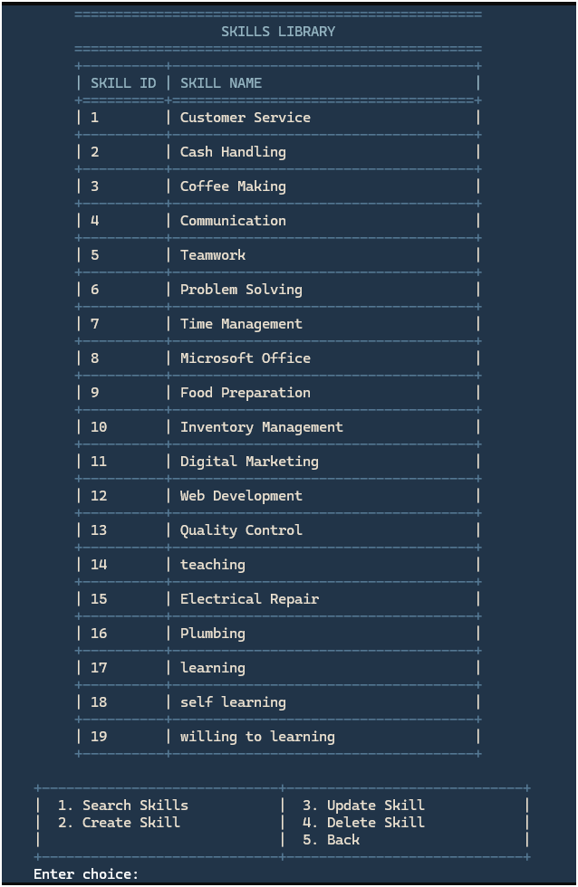

Figure 3.6.4.13 View User Skills

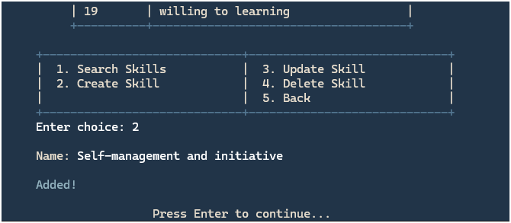

Figure 3.6.4.14 Admin Create Skill

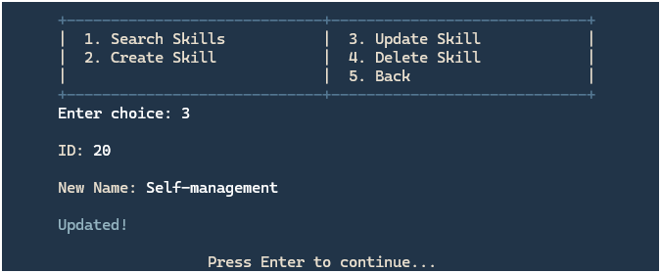

Figure 3.6.4.15 Admin Update Skill

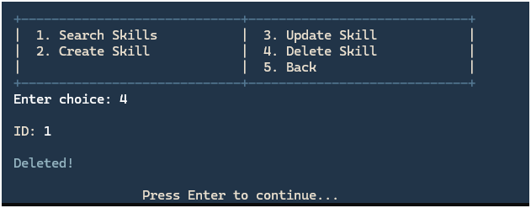

Figure 3.6.4.16 Admin Delete Skill

* search skills same as Figure 3.6.4.12 Admin Search App Id

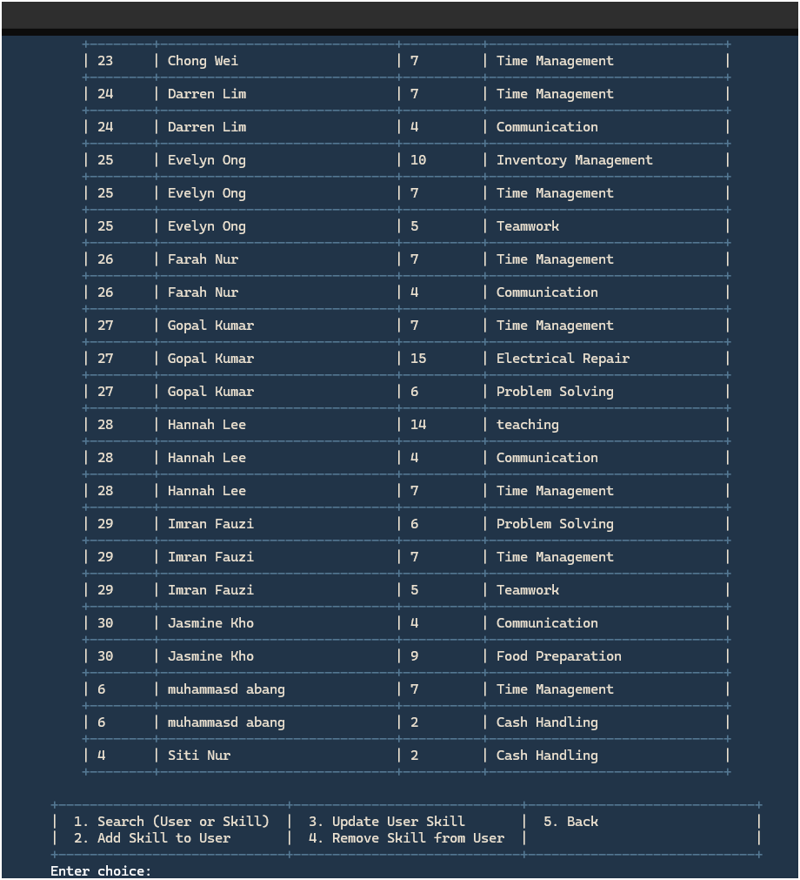

Figure 3.6.4.17 Admin View User Skills

* Search same function as Figure 3.6.4.12 Admin Search App Id
* Add skill to user same function as Figure 3.6.4.14 Admin Create Skill
* Update user skill same function as Figure 3.6.4.15 Admin Update Skill
* Remove skill to user same function as Figure 3.6.4.16 Admin Delete Skill

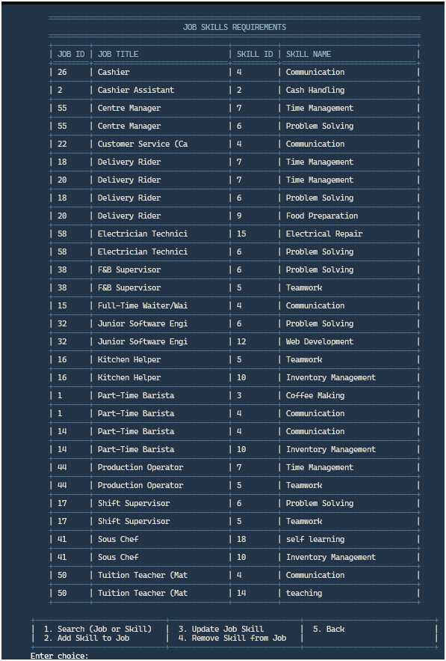

Figure 3.6.4.18 Admin View Job Skill

* Search same function as Figure 3.6.4.12 Admin Search App Id
* Add skill to user same function as Figure 3.6.4.14 Admin Create Skill
* Update user skill same function as Figure 3.6.4.15 Admin Update Skill
* Remove skill to user same function as Figure 3.6.4.16 Admin Delete Skill

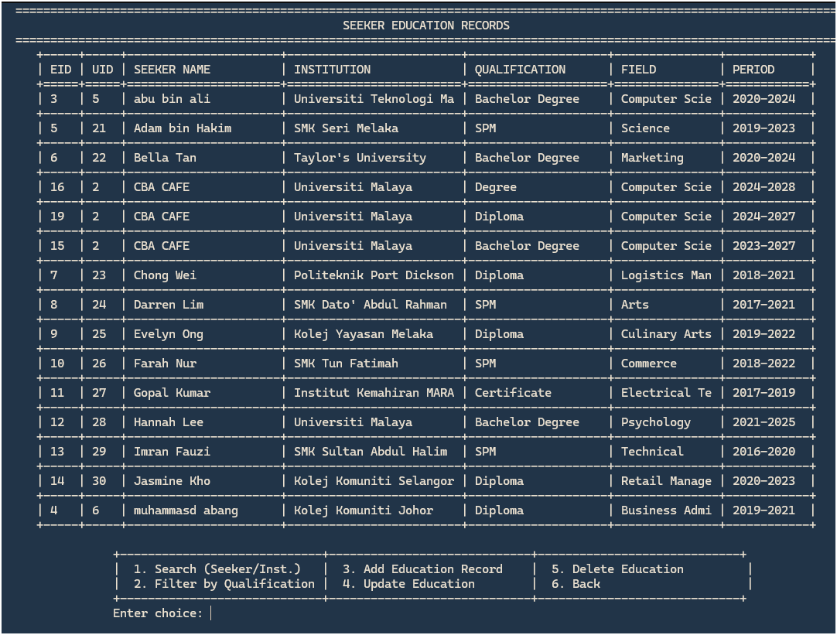

Figure 3.6.4.19 Admin View Seeker Education

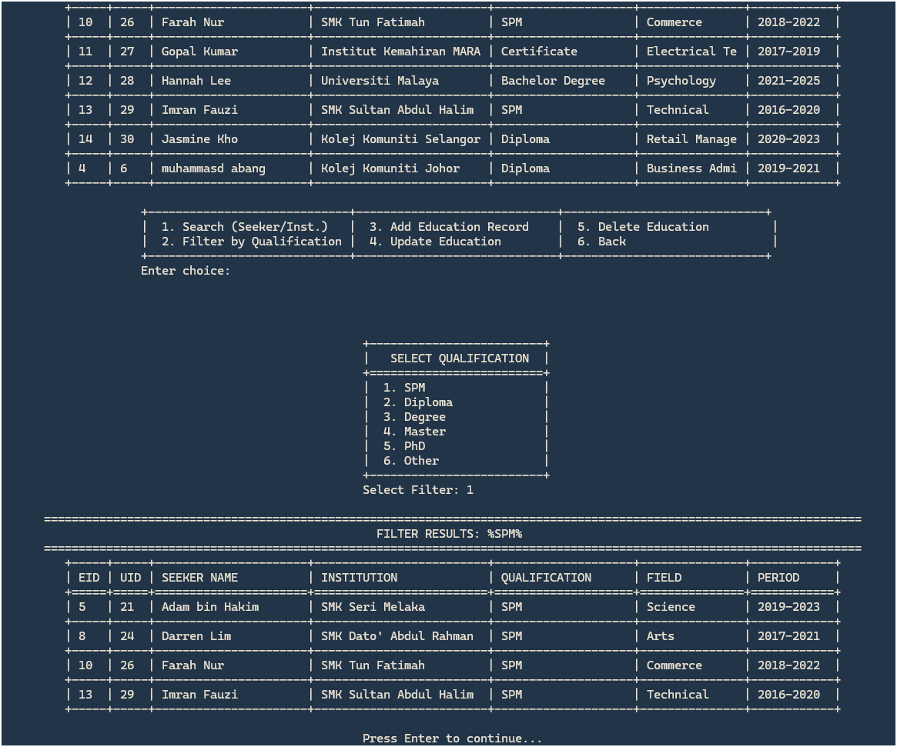

Figure 3.6.4.20 Admin Filter By Qualification



Figure 3.6.4.21 Admin Add Education Record

* Search same function as Figure 3.6.4.12 Admin Search App Id
* Delete Education same function as Figure 3.6.4.16 Admin Delete Skill

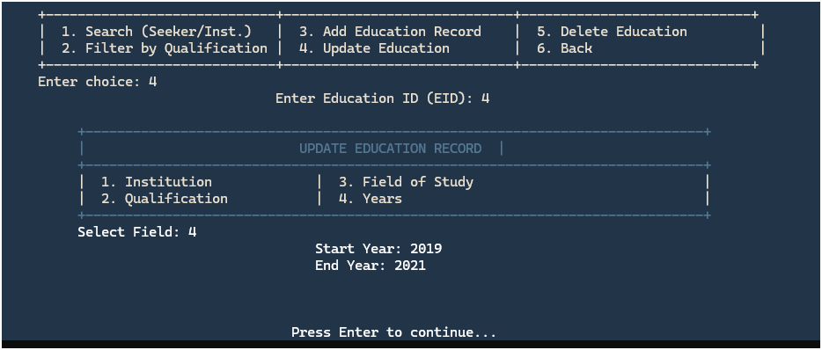

Figure 3.6.4.22 Admin Update Education

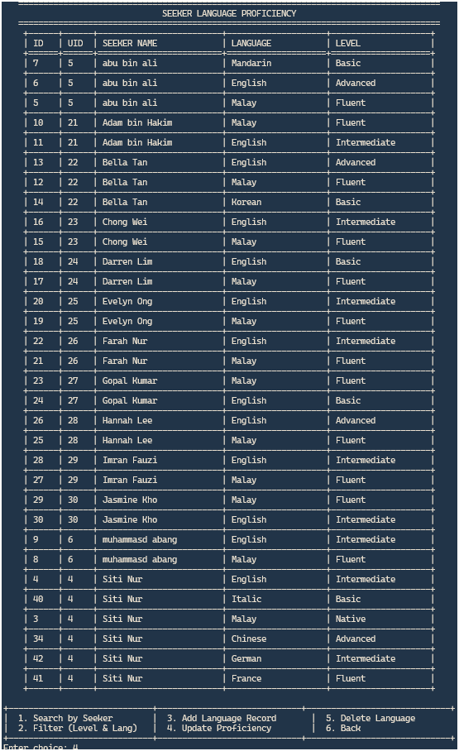

Figure 3.6.4.23 Admin View Seeker Languages

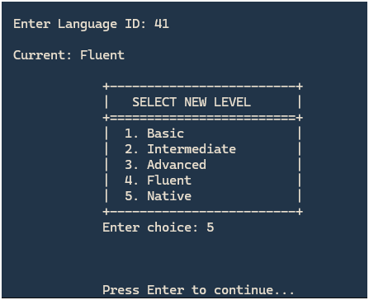

Figure 3.6.4.24 Admin Update Proficiency

* Search by seeker same function as Figure 3.6.4.12 Admin Search App Id
* Add language record to user same function as Figure 3.6.4.14 Admin Create Skill
* Delete language same function as Figure 3.6.4.16 Admin Delete Skill
* Filter (level & lang) same function as Figure 3.6.4.20 Admin Filter By Qualification

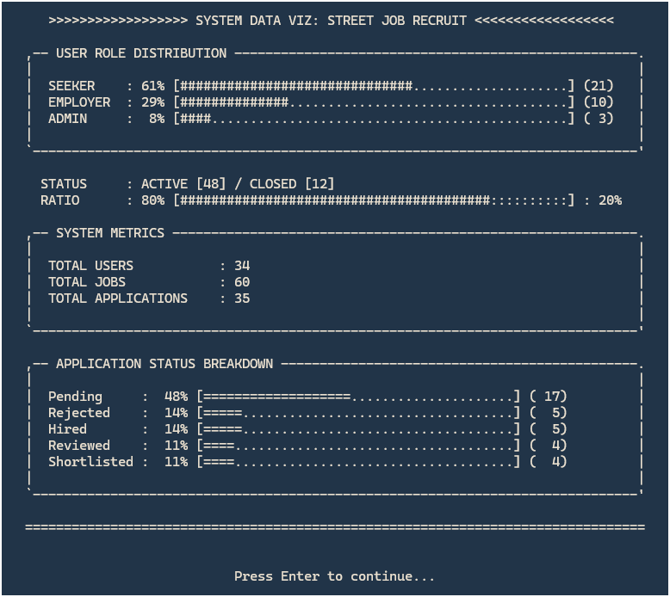

Figure 3.6.4.25 Admin View Database Statistics

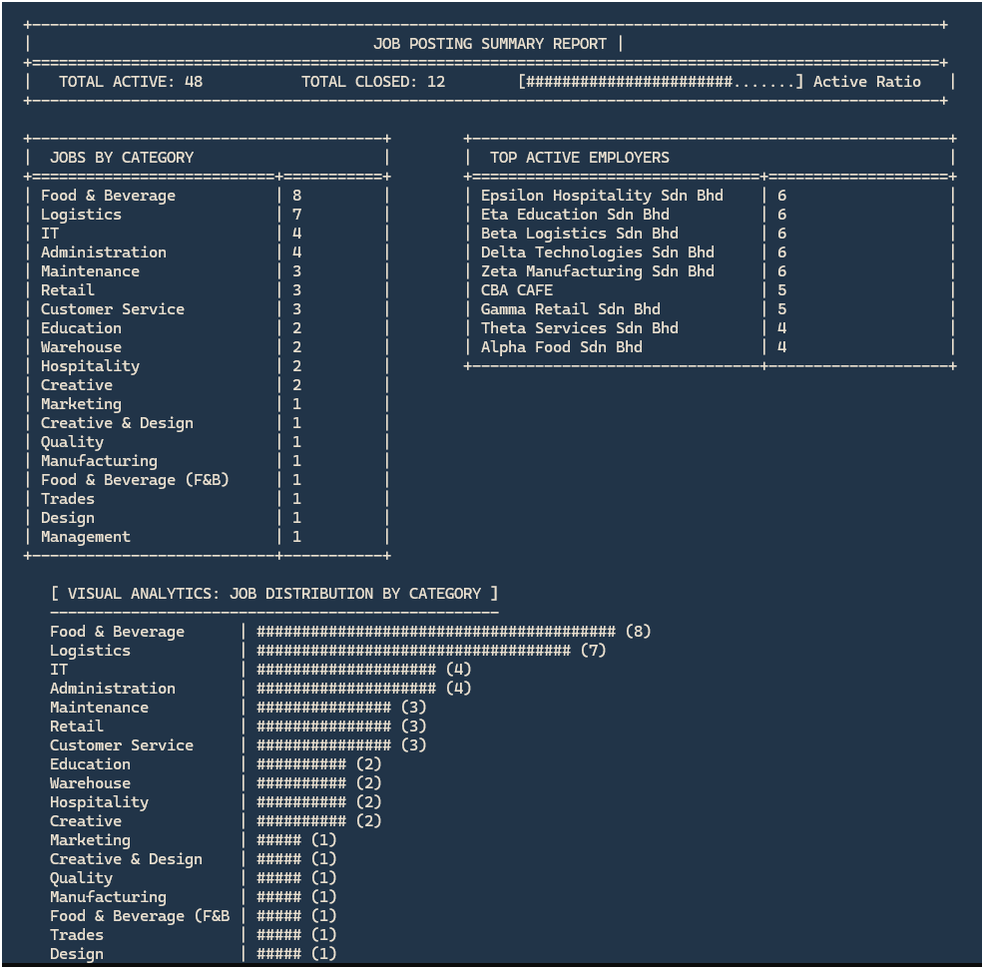

Figure 3.6.4.26 Admin Job Posting Summary

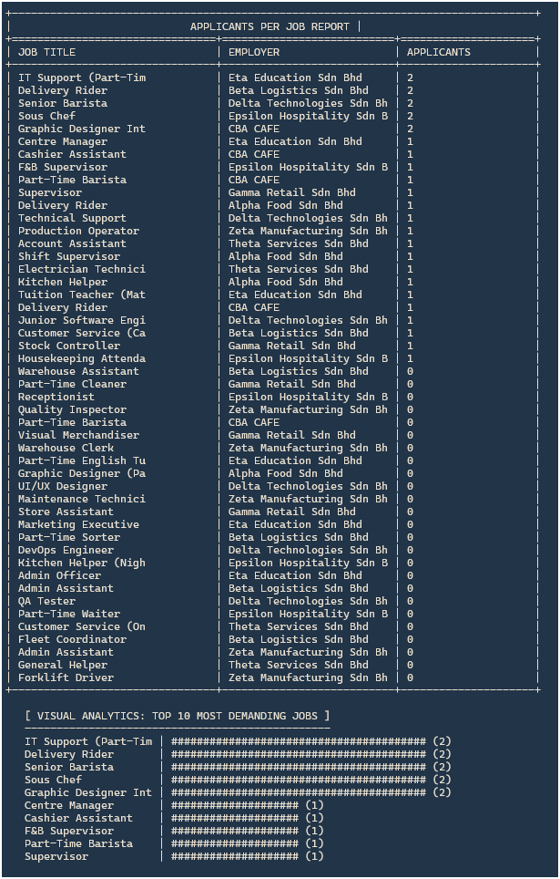

Figure 3.6.4.27 Admin Applicants Per Job

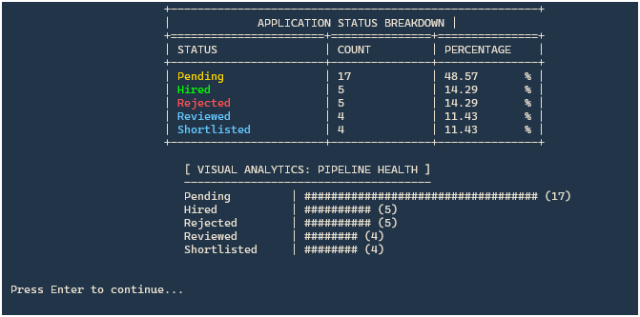

Figure 3.6.4.28 Admin App Status Breakdown

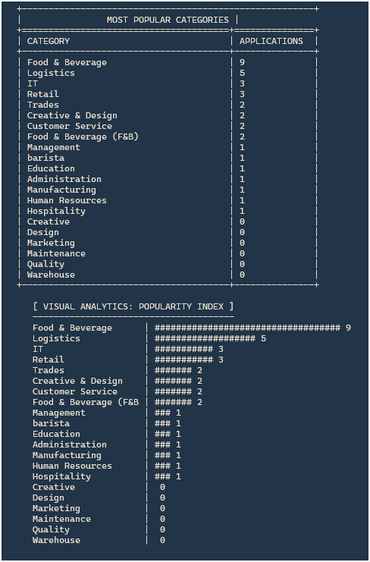

Figure 3.6.4.29 Admin Most Applied Categories

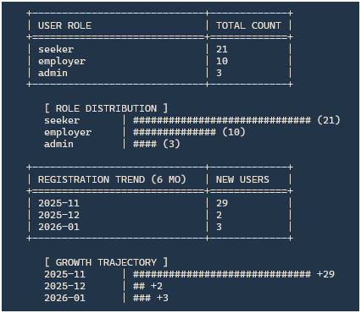

Figure 3.6.4.30 Admin Registered Users Breakdown

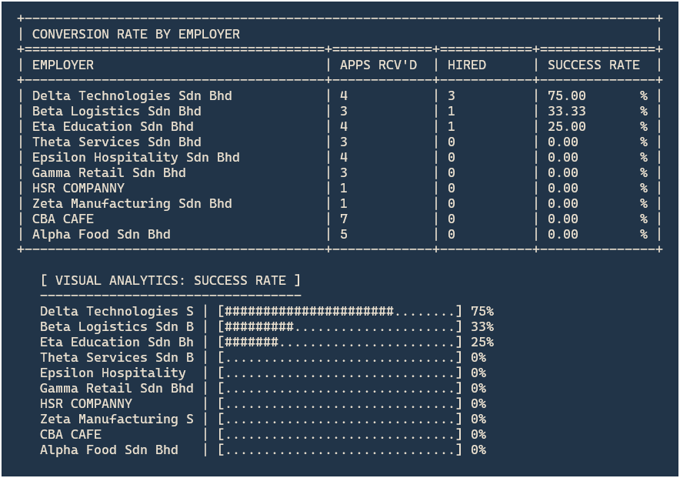

Figure 3.6.4.31 Admin Conversion Rate Report

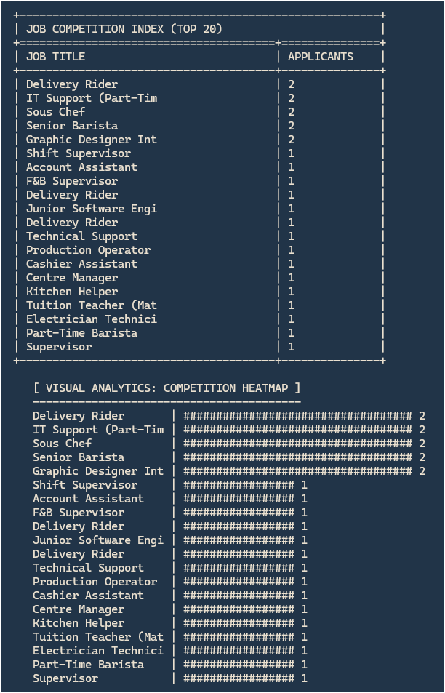

Figure 3.6.4.32 Job Competition Index

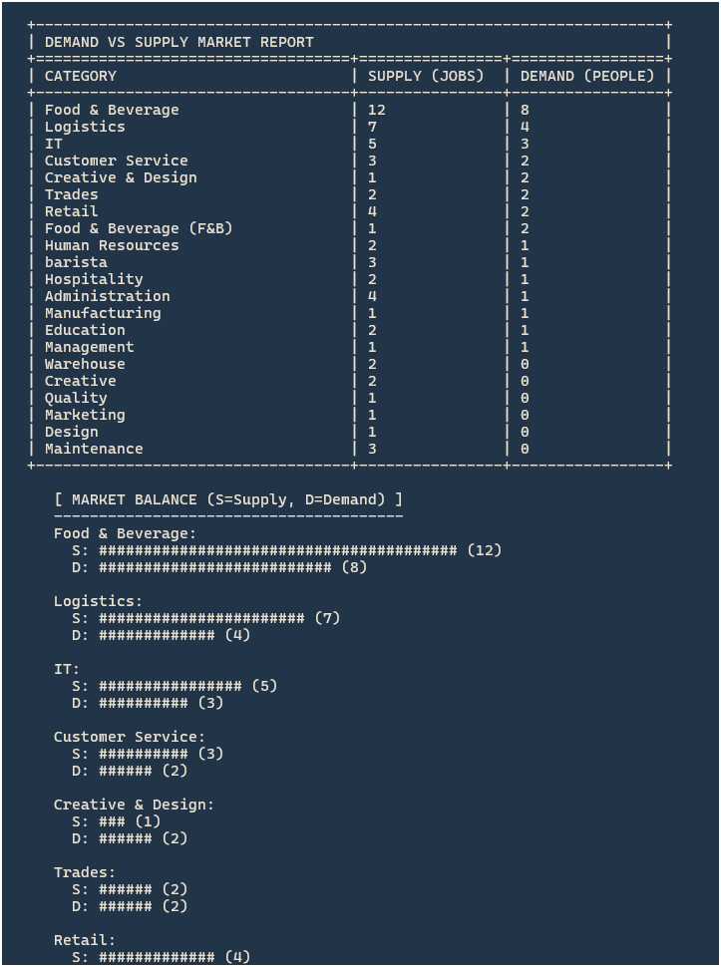

Figure 3.6.4.33 Admin Demand vs Supply Report

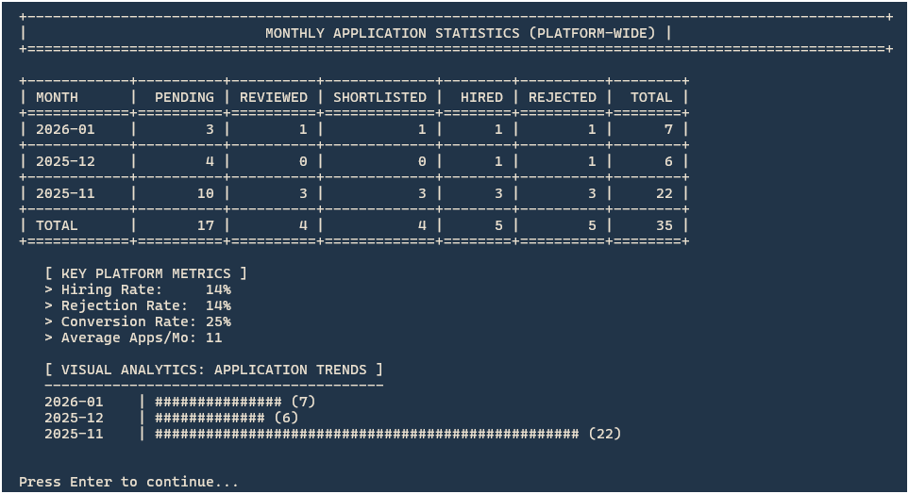

Figure 3.6.4.34 Admin Monthly App Statistics

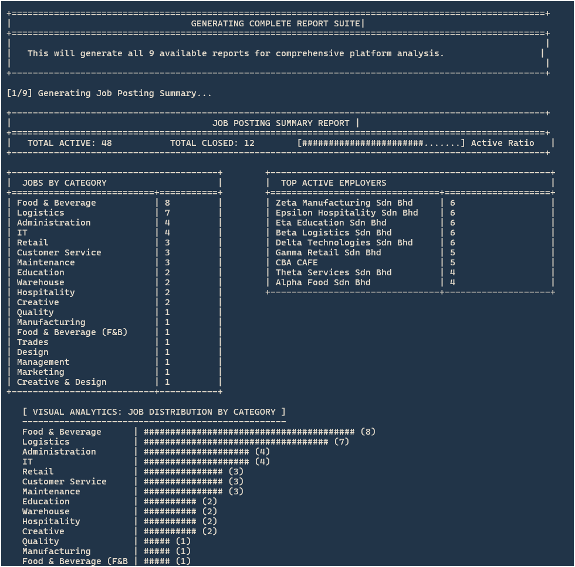

Figure 3.6.4.35 Admin GENERATE ALL REPORTS

# IMPLEMENTATION

## Naming Convention

In the StreetJobRecruit system, a consistent naming convention is applied to ensure code readability and database maintainability.

1. **Variable Naming:** Variables are named using camelCase (e.g., userRole, jobID) to easily distinguish them from class names and functions. Meaningful names are chosen to reflect the data they hold, avoiding single-letter variables except for loop counters (e.g., i, j).
2. **Class Naming:** Classes representing system entities (e.g., User, JobApplication, DatabaseConnection) use **PascalCase**. This aligns with standard C++ object-oriented practices.
3. **Constant Naming:** Constants, such as maximum array sizes or fixed database configuration strings, are written in **UPPER_CASE** with underscores (e.g., MAX_USERS, DB_HOST) to clearly indicate immutable value

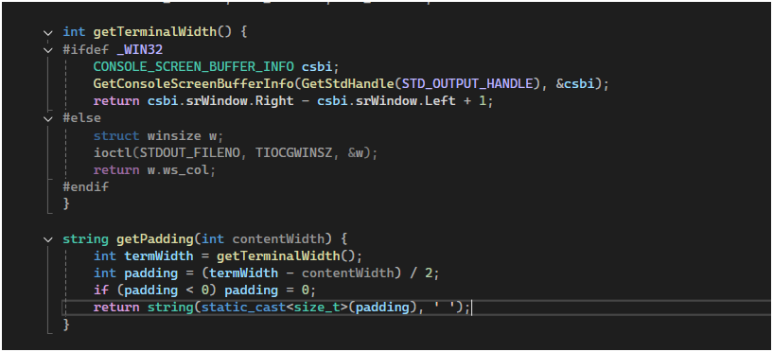

Figure 4.1.1 Naming Convention

## Function

In the StreetJobRecruit System, functions are the primary building blocks used to modularize code, improve readability, and prevent redundancy. We implemented two distinct types of functions:

1. **Module Handlers (Void Functions):** These are large functions responsible for handling entire screen logic, such as displaying menus or processing user input. They often take the Database Connection (sql::Connection*) as a parameter to perform operations.
2. **Utility Helpers (Return Functions):** These are smaller, reusable functions used for UI formatting (like centering text) or data calculation. They return specific data types (string, int) to be used by other parts of the system.

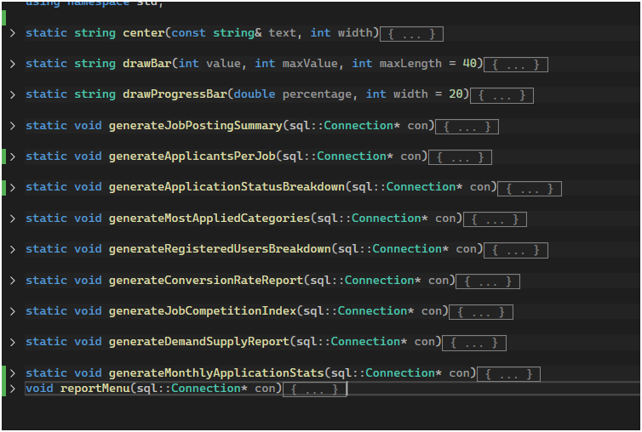

**Figure 4.2.1 Function**

## Array

In the StreetJobRecruit system, Arrays (specifically implemented as std::vector in C++) are used to store and manipulate dynamic collections of data elements. Unlike static C-style arrays with a fixed size, std::vector allows the system to handle varying amounts of data efficiently, such as a changing number of job applications, user roles, or monthly statistics.

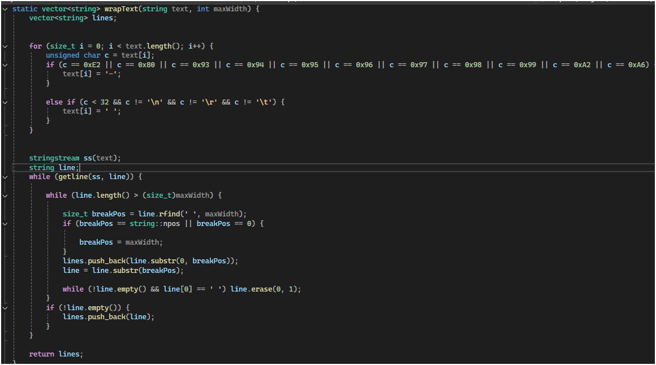

Figure 4.3.1 Array

## Selection

Selection control structures allow the program to choose different paths of execution based on specific conditions. In the StreetJobRecruit System, we use:

1. **switch statements** for menu navigation, allowing the user to select distinct modules (e.g., "Manage Users" vs. "Manage Jobs") based on an integer input.
2. **if-else statements** for conditional logic, such as building dynamic SQL queries. For example, when searching for a job, the system checks *if* a filter criteria exists before appending it to the query string.

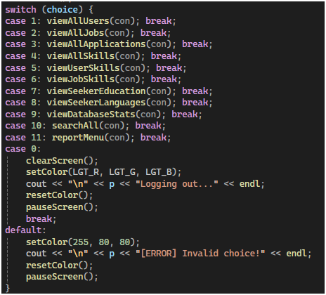

Figure 4.4.1 switch statements



Figure 4.4.2 if-else statements

## Control

Control structures, specifically loops, allow the system to execute a block of code multiple times. In the StreetJobRecruit System, we implemented:

1. **do-while loops:** Used for menu navigation. This ensures the menu is displayed at least once and keeps the user on the screen until they explicitly choose to "Back" or "Exit" (condition choice != 0).
2. **while loops:** Used to iterate through database result sets. When the system fetches multiple rows (like a list of jobs), the loop continues as long as res->next() returns true.

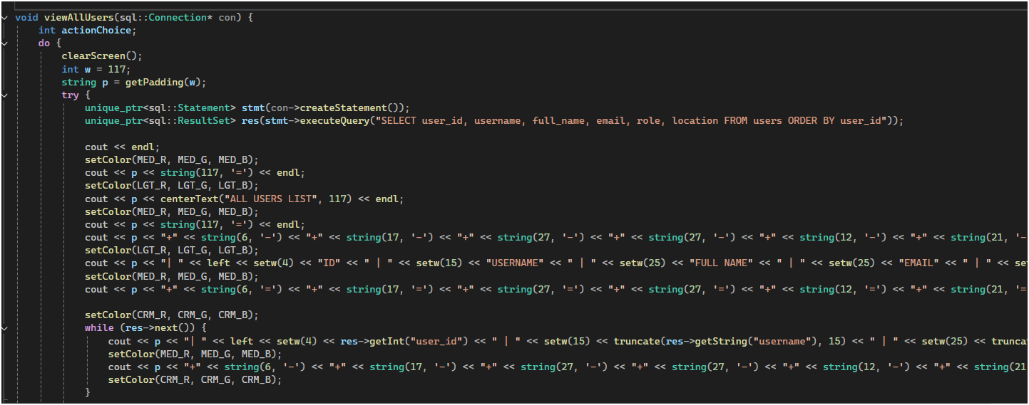

Figure 4.5.1 Control

## Pointer

Pointers are used to pass the database connection between functions without disconnecting.

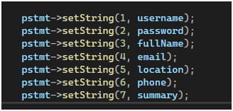

Figure 4.6.1 Pointer

## Error Handling

Error handling is a programming technique used to ensure the system continues to operate smoothly even when unexpected events occur. In the StreetJobRecruit System, we implemented:

1. **try-catch Blocks:** All database interactions are wrapped in try-catch blocks. If a SQL command fails (e.g., trying to create a user with a duplicate email), the system catches the sql::SQLException and displays a readable error message instead of crashing the entire application.
2. **Input Stream Validation:** When the system expects a numerical input (like a menu choice), we check cin.fail(). If the user accidentally enters text, the system clears the error flag and ignores the invalid input to prevent infinite loops.

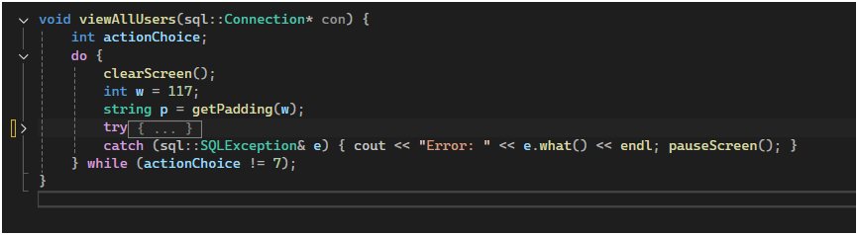

Figure 4.7.1 try-catch Blocks

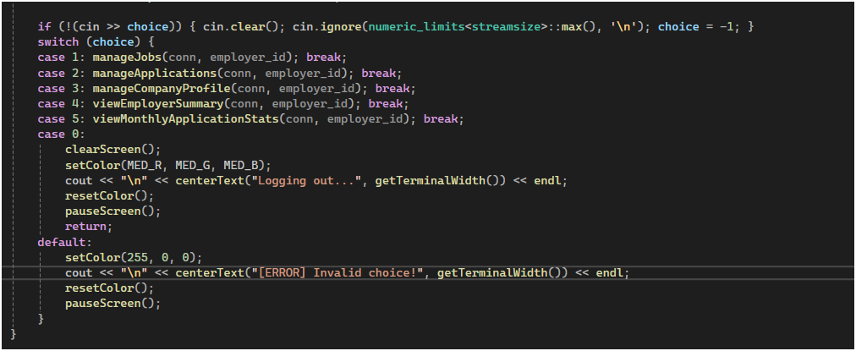

Figure 4.7.2 Input Stream Validation

## Business Rule Implementation

Business rules are the policies and constraints that govern the behavior of the system. In the StreetJobRecruit System, a core business rule is that **"Job Seekers may only interact with Job Postings that are currently marked as Active."** This rule protects the recruitment process by ensuring that applications are only submitted to open vacancies, while allowing Employers to "Close" (hide) jobs without deleting them from the database.

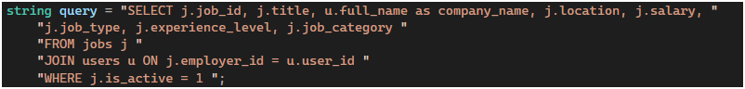

**Figure 4.8.1 Business Rule Implementation**

## Complex Calculation Implementation

In the StreetJobRecruit System, complex calculations are implemented to derive meaningful business insights from raw data. Instead of simple arithmetic, the system performs **Aggregate Ratio Calculations** involving multiple database tables. A key example is the **"Job Competition Index"**, which measures the difficulty of securing a job in a specific category.

The calculation follows this logic:

1. **Aggregation:** It counts the total number of applications received for a category.
2. **Normalization:** It divides that count by the number of unique active jobs in that category.
3. **Interpretation:** The C++ logic then interprets this numerical index to assign a qualitative label (e.g., "High Competition" vs. "Low Competition").

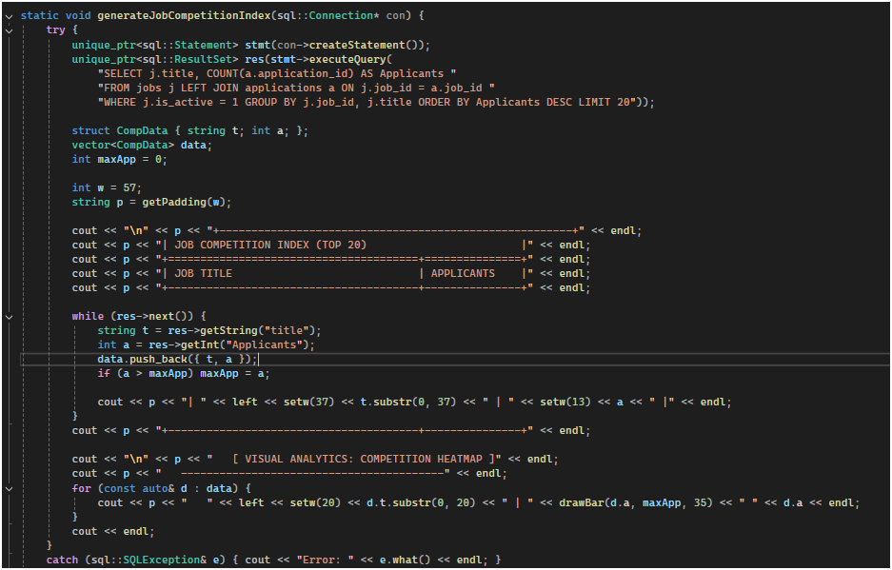

Figure 4.9.1 Complex Calculation Implementation

## Report Generation for Analysis Implementation

In the StreetJobRecruit System, report generation goes beyond simple data listing. The system implements an **Analytical Engine** that aggregates raw data (using SQL COUNT, SUM, GROUP BY) and visualizes it directly in the console.

The implementation involves two key steps:

1. **Data Aggregation:** The system executes complex SQL queries to calculate metrics like "Job Competition Index" or "Monthly Application Trends."
2. **Visual Rendering:** A custom C++ algorithm converts these numerical percentages into dynamic ASCII progress bars (e.g., [#####.....]), allowing the Administrator to instantly gauge performance metrics without needing external tools.

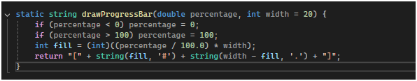

Figure 4.10.1 Visual Rendering

# CONCLUSION

## Constraints

The StreetJobRecruit System is designed as a standalone console application that meets the core project requirements but operates with specific technical limitations. It relies heavily on Windows-specific libraries like <windows.h> for interface formatting, which makes the software platform-dependent and incompatible with Linux or macOS environments. Additionally, because it is a linear executable without a Graphical User Interface (GUI), it is restricted to a single user session at a time and requires a direct local network connection to the MySQL database, preventing simultaneous multi-user access or remote deployment.

## Future Improvements

To address the current technical limitations of the StreetJobRecruit System, future development should prioritize migrating the architecture from a standalone Windows console application to a scalable web-based platform. This transition will resolve platform dependency issues and enable concurrent multi-user access, allowing Employers and Seekers to interact with the system simultaneously from any device. Additionally, moving the local MySQL database to a cloud environment and integrating an SMTP notification service will ensure remote accessibility and real-time user engagement, effectively transforming the current prototype into a fully deployable enterprise solution.

# REFERENCES

Elmasri, R., and Navathe, S. B. (2015). *Fundamentals of Database Systems*. 7th Ed. Boston: Pearson Education. 500-540. (Covers your 3NF and normalization logic).

Gamma, E., Helm, R., Johnson, R., and Vlissides, J. (1994). *Design Patterns: Elements of Reusable Object-Oriented Software*. Reading, MA: Addison-Wesley. (Covers your modular function and class structure).

MySQL AB. (2025). *MySQL Connector/C++ Developer Guide*. Accessed January 13, 2026. <https://dev.mysql.com/doc/connector-cpp/en/>.

Oracle Corporation. (2024). *MySQL 8.0 Reference Manual*. Accessed January 12, 2026. <https://dev.mysql.com/doc/refman/8.0/en/>.

Stroustrup, B. (2013). *The C++ Programming Language*. 4th Ed. Upper Saddle River, NJ: Addison-Wesley.

Salam, S., Wan Bejuri, W. Y., Mozamir, M. S., Kanchymalav, K., Abd Karim Ishigaki, S., Mohd Salleh, N., Arbain, N. A., Ismail, M. H., & Abdullah, M. F. (2025). *Building Console-Based Information Systems in C++: A Practical Guide to CRUDS Operations, Complex Calculations, and Data Analysis Reports*. Faculty of Information and Communication Technology, Universiti Teknikal Malaysia Melaka.

All sources :

<https://drive.google.com/drive/folders/1rvI5BjUnEEdWeplKUFSMd8nnNfc_HmBh?usp=drive_link>